faust2sam

Faust Integration with the Analog Devices

SHARC Audio Module Platform

Gregory Pat Scandalis

support@moforte.com

Document Revision R1.4

**Document History:**

GPS 9/14/2017 Document Started

GPS 12/09/2017 First revision (R1.1) completed

GPS 01/02/2018 Revisions

GPS 04/28/2018 Final revisions

GPS 06/02/2018 Redid MIDI assignment tables.

GPS 06/11/2018 Added in block diagram and workflow images

GPS 06/11/2018 Removed Faust additions, faust2sam is not a part of the faust dist

1. 1.0 faust2sam Overview 4

1.1 Faust 4

1.2 faust2sam 5

1.3 Useful Faust References 5

1.4 The Faust Compiler 5

1.5 Prerequisites (Mac/OS X) 6

1.6 Workflow 6

1. 2.0 Installing MacPorts 7
2. 3.0 Downloading, Compiling and Installing Faust 8

3.1 Downloading Faust 8

3.2 Compiling Faust 8

3.3 Installing Faust 8

1. 4.0 The CCES Bare Metal Project 9
2. 5.0 Setting up Faust Editing Mode in emacs 10
3. 6.0 MIDI in Faust 11

6.1 Mapping MIDI messages to Faust Control 11

6.2 MIDI Conventions for the Pots and Push Buttons on the DIY Board 12

1. 7.0 faust2sam workflow 13
2. 8.0 Example Workflow – MIDI Controlled Volume on Core 1 15

8.1 The Faust Code for the MIDI Controlled Volume 15

8.2 Building a Test GUI for the MIDI Controlled Volume 15

8.3 Looking at the Block Diagram for the MIDI Controlled Volume 16

8.4 Running faust2sam 16

8.5 The CCES Baremetal Framework 17

8.6 Brief Notes on Compiling and Running the Algorithm in CCES 18

1. 9.0 Example Workflow – MIDI Controlled Reverb on Core 1 19

9.1 The Faust Code for the MIDI Controlled Reverb 19

9.2 Building a Test GUI for the MIDI Controlled Reverb 19

9.3 Looking at the Block Diagram for the MIDI Controlled Reverb 20

9.4 Running faust2sam 20

1. 10.0 Example Workflow – MIDI Sawtooth Synth (Core 1) 21

10.1 The Faust Code for the MIDI Controlled Sawtooth Synth 21

10.2 Building a Test GUI for the MIDI Controlled Sawtooth Synth 22

10.3 Looking at the Block Diagram for the MIDI Controlled Sawtooth 23

10.4 Running faust2sam 24

1. 11.0 Example Workflow – MIDI Virtual Analog Synth (Core1) /Effects (Core 2) 25

11.1 The Faust Code for the Virtual Analog Synth (Core 1) 25

11.2 Building a Test GUI for the Virtual Analog Synth 26

11.3 Looking at the Block Diagram for the Virtual Analog Synth 27

11.4 Running faust2sam 28

11.5 The Faust Code for the Effects Chain (Core 2) 29

11.6 Building a Test GUI for the Effects Chain 30

11.7 Looking at the Block Diagram for the Effects Chain 31

11.8 Running faust2sam 32

11.9 The CCES Baremetal Framework 32

11.10 MIDI Assignments for the Virtual Analog Algorithm 33

11.11 MIDI Assignments for the Effects Chain Algorithm 34

11.12 The Virtual Analog/Effects Chain TouchOSC UI 36

1. 12.0 Conclusion 38

# faust2sam Overview

## Faust

[Faust](http://faust.grame.fr) (Functional Audio Stream) is an open-source, functional programming language, specifically designed for real-time audio signal processing and synthesis. Faust generates C++, as well as other target languages, for signal processing applications.

In addition to generating efficient inner loops in C++, Faust also:

* Can generate test GUIs for prototyping algorithms
* Can generate easy-to-read hierarchical block diagrams directly from the Faust source, which graphically illustrate signal flow and processing.
* Provide a runtime system that supports MIDI for both voice allocation and parameter control.

Below is an example of the complete Faust code for a simple MIDI controlled sawtooth synthesizer:

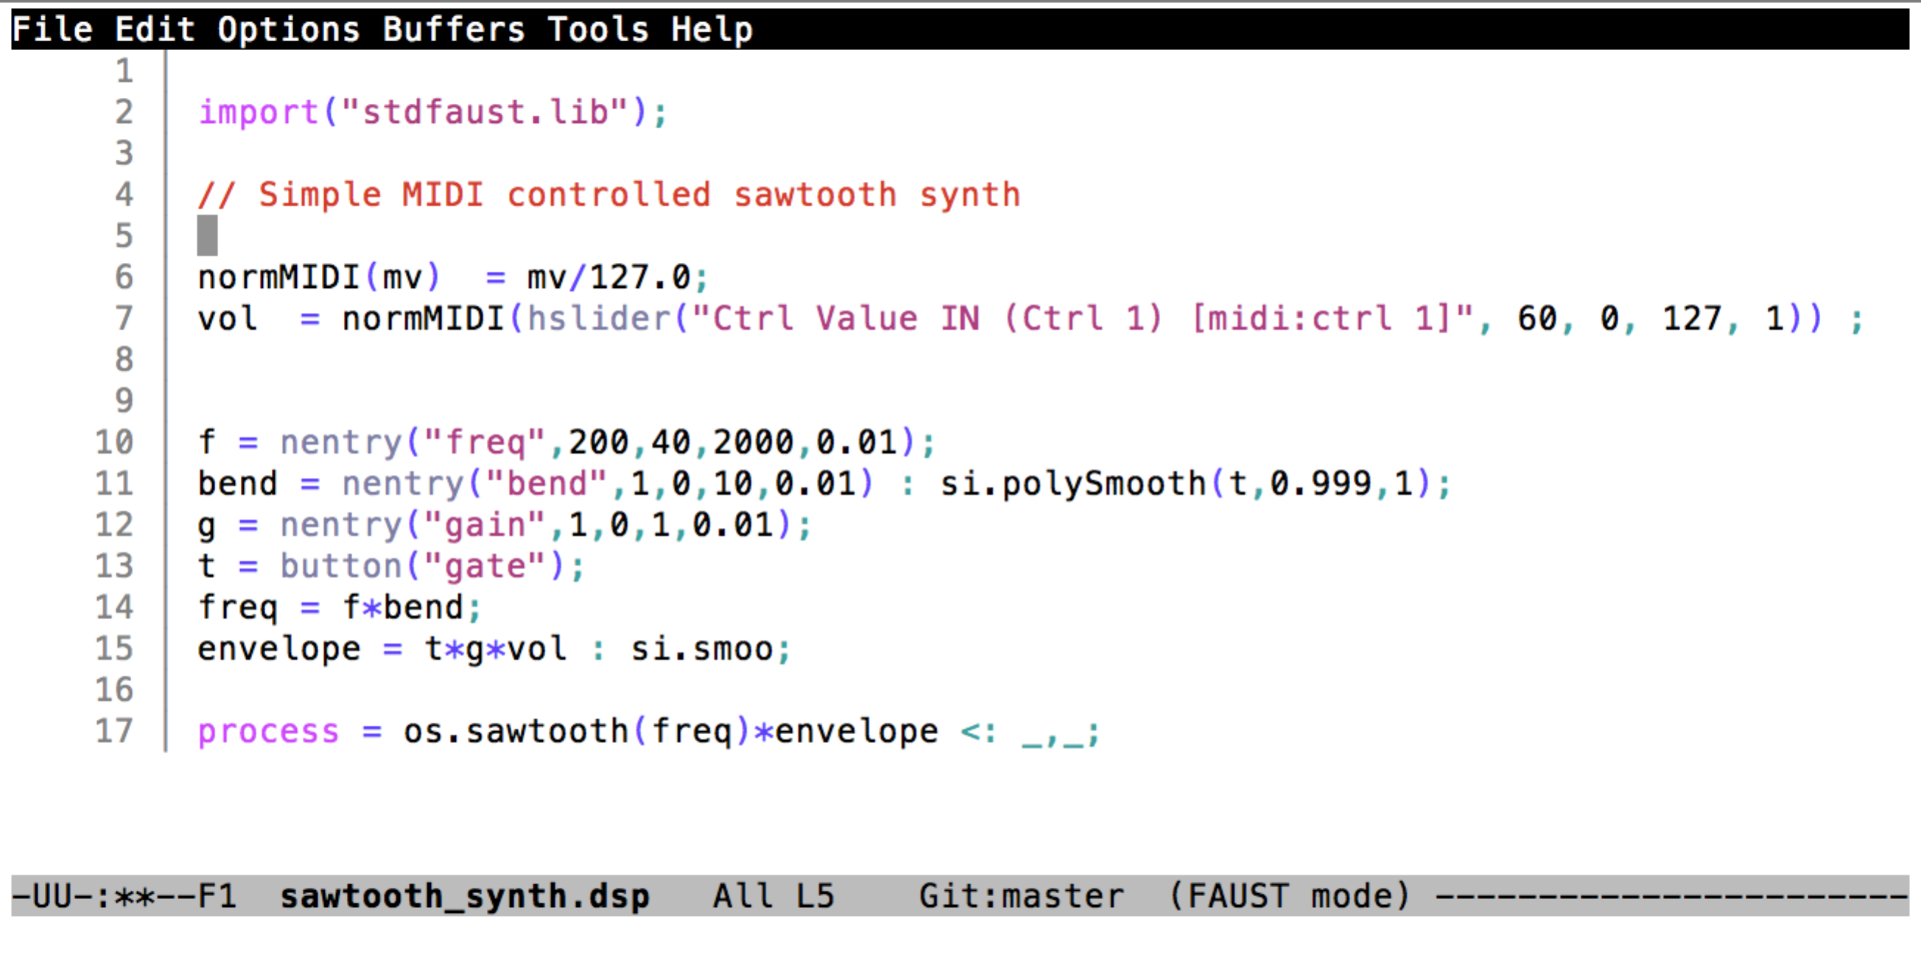

Chapter 10 will go into more detail about this example, its MIDI control and its block diagram.

## faust2sam

Faust programs may be targeted for many different platforms via what is known as “an architecture”. The script **faust2sam** calls the Faust compiler using an architecture that is specific to the SHARC Audio Module platform. When an algorithm is compiled using **faust2sam**, three C++ source code files are generated for the SHARC Audio Module platform. These files may then be inserted into a [Cross Core Embedded Studio](http://www.analog.com/en/design-center/processors-and-dsp/evaluation-and-development-software/adswt-cces.html) (CCES) workspace that can be compiled into an algorithm that runs on the SHARC Audio Module platform.

## Useful Faust References

This document will **not** go into detail about the Faust language. There are a number of good references and tutorials for Faust. Here are some useful references for learning more about Faust.

* The main Faust website: <http://faust.grame.fr>
* Faust Documentation: <http://faust.grame.fr/Documentation/>
* Dr. Julius O. Smith III’s site about Faust: <https://ccrma.stanford.edu/~jos/spf/>
* Romain Michon’s Faust tutorials: <https://ccrma.stanford.edu/~rmichon/faustTutorials/>
* Romain’s online Faust course: <https://ccrma.stanford.edu/~rmichon/faustWorkshops/course2015/>
* The Wikipedia entry: <https://en.wikipedia.org/wiki/FAUST_(programming_language)>

## The Faust Compiler

At the present time, Faust must be downloaded to a host computer, compiled and installed. All prototyping is done on the host computer. Currently, Faust is easily compiled and run on Mac/OS X machines and Linux machines. This document describes how to download, compile and install Faust on a Mac/OS X machine.

**In the very near future the Faust compiler will be able to run on a remote server. All prototyping will be done in a web browser and the browser will be able to export C++ targeted for the SHARC Audio Module platform. Currently the Faust team is testing this new technology.**

## Prerequisites (Mac/OS X)

A number of prerequisites are needed in order to compile Faust and develop with Faust.

* xcode needs to be installed and the command line tools need to be installed so that Faust can be compiled.
* Before Faust is downloaded macports should be installed along with a number of useful packages. macports is a package manager for ports of Linux tools for the Mac. The most important package to install from macports is the QT5 package, which provides libraries for Faust to build GUIs used for prototyping algorithms.
* Faust will need to be downloaded as well. Faust will be compiled and installed on the system.
* A set of additions to Faust to support **faust2sam** will need to be installed. These are installed with the **add\_faust\_additions.tcsh** script.
* Optionally a **faust-mode** elisp file can be installed for emacs to support visual editing of Faust code using emacs.

## Workflow

The typical workflow using Faust would be:

* Create algorithm in Faust. MIDI control can be attached to the algorithm in the Faust code using the MIDI metadata mechanism (see chapter 7).
* Use **faust2caqt** to create a running GUI app on the host computer (Mac/OS X) so that the algorithm can be tested. This GUI app can process audio (on the Mac host) as well as MIDI.
* Optionally the developer can use **faust2firefox** to generate a hierarchical block diagram for the algorithm to examine the algorithm’s signal flow.
* Once the developer is satisfied with the algorithm **faust2sam** can be used to generate a set of C++ files for the algorithm that are intended to be used with a CCES framework.
* These 3 source files can be copied to the Faust directory in the CCES framework. The framework can then be compiled and downloaded to the platform.

# Installing MacPorts

MacPorts is a package manager for ports of Linux tools for the Mac. Before Faust is downloaded MacPorts should be installed along with a number of useful packages. The most important package to install from macports is the QT5 package, which provides libraries for Faust to build GUIs used for prototyping algorithms.

The main site for macports is: <https://www.macports.org>

The installation page is: <https://www.macports.org/install.php>

Once macports is installed QT5 should be installed with the command

% sudo port install qt5

This command will install/compile QT 5 along with its dependencies. This install can take some time, as much as an hour or more.

# Downloading, Compiling and Installing Faust

## Downloading Faust

The latest Faust can be cloned from github. Typically this would be cloned into ~/Developer/faust:

% cd ~/Developer

% git clone https://github.com/grame-cncm/faust.git

## Compiling Faust

Faust can be compiled like this:

% cd ~/Developer/faust

% make

The compile will run for about 5 minutes.

## Installing Faust

Faust can be installed on your system with this:

% cd ~/Developer/faust

% sudo make install

You can test that Faust is installed by invoking the **faust –version** command.

% faust --version

FAUST : DSP to C, C++, Rust, LLVM IR, JAVA, JavaScript, asm.js, WebAssembly (wast/wasm), Interpreter compiler, Version 2.5.15

Copyright (C) 2002-2018, GRAME - Centre National de Creation Musicale. All rights reserved.

# The CCES Bare Metal Project

The bare metal framework is a part of the Analog Devices SHARC Audio Module platform installer, which contains a CCES project workspace that can be used to build SHARC Audio Module platform.

Information on how to get the Bare Metal Framework can be found here:

[https://wiki.analog.com/resources/tools-software/sharc-audio-module/baremetal](https://wiki.analog.com/resources/tools-software/sharc-audio-module/baremetal" \t "_blank)

Faust algorithms can be added to this framework in the “faust” directory, which will be explained in section 8.5 (below)

# Setting up Faust Editing Mode in emacs

Optionally for users of emacs, a Faust editing mode can be setup in the. emacs file.

Below is an example Faust program in emacs Faust editing mode.



The elisp file for Faust editing mode and instructions for set it can be found here:

<https://github.com/rukano/emacs-faust-mode>

# MIDI in Faust

## Mapping MIDI messages to Faust Control

Faust has a number of meta data conventions for mapping MIDI messages into Faust control. Below is the simple MIDI controlled sawtooth synth, which illustrates how this control mapping is down. In the example below nentry() is a numerical entry object that can be mapped to receive specific MIDI values. A number of metadata values are reserved to have specific mapping functions.

* freq – If a MIDI noteOn event is received it’s MIDI keyNumber is mapped to a frequency.
* bend – if a MIDI pitchBend message is received it is mapped to a bend value.
* gain – if a MIDI noteOn message is received it’s velocity value is mapped to a gain value which ranges from [0 .. 1.0]
* gate – if MIDI noteOn/noteOff messages are received they are mapped to a gate value (0/1)
* [midi:ctrl 1] – A Faust control (slider, etc.) can be mapped to listen to a MIDI continuous controller.



## MIDI Conventions for the Pots and Push Buttons on the DIY Board

The pots and push buttons on the DIY board can be used to control key algorithm parameters. By default the pots are mapped to MIDI CC-2,3,4 and the push button switches are mapped to MIDI CC-102,103,104,105.

The algorithm examples that are provided use these conventions. For example, the effects algorithm is “echo : flange : chorus : reverb”. For this algorithm each of the four push buttons turns on a different effects unit. The first pot is the echo feedback, the second pot is the reverb room size and the third pot is the reverb damping.

# faust2sam workflow

The typical workflow using faust to design algorithms for the SHARC Audio Module is:

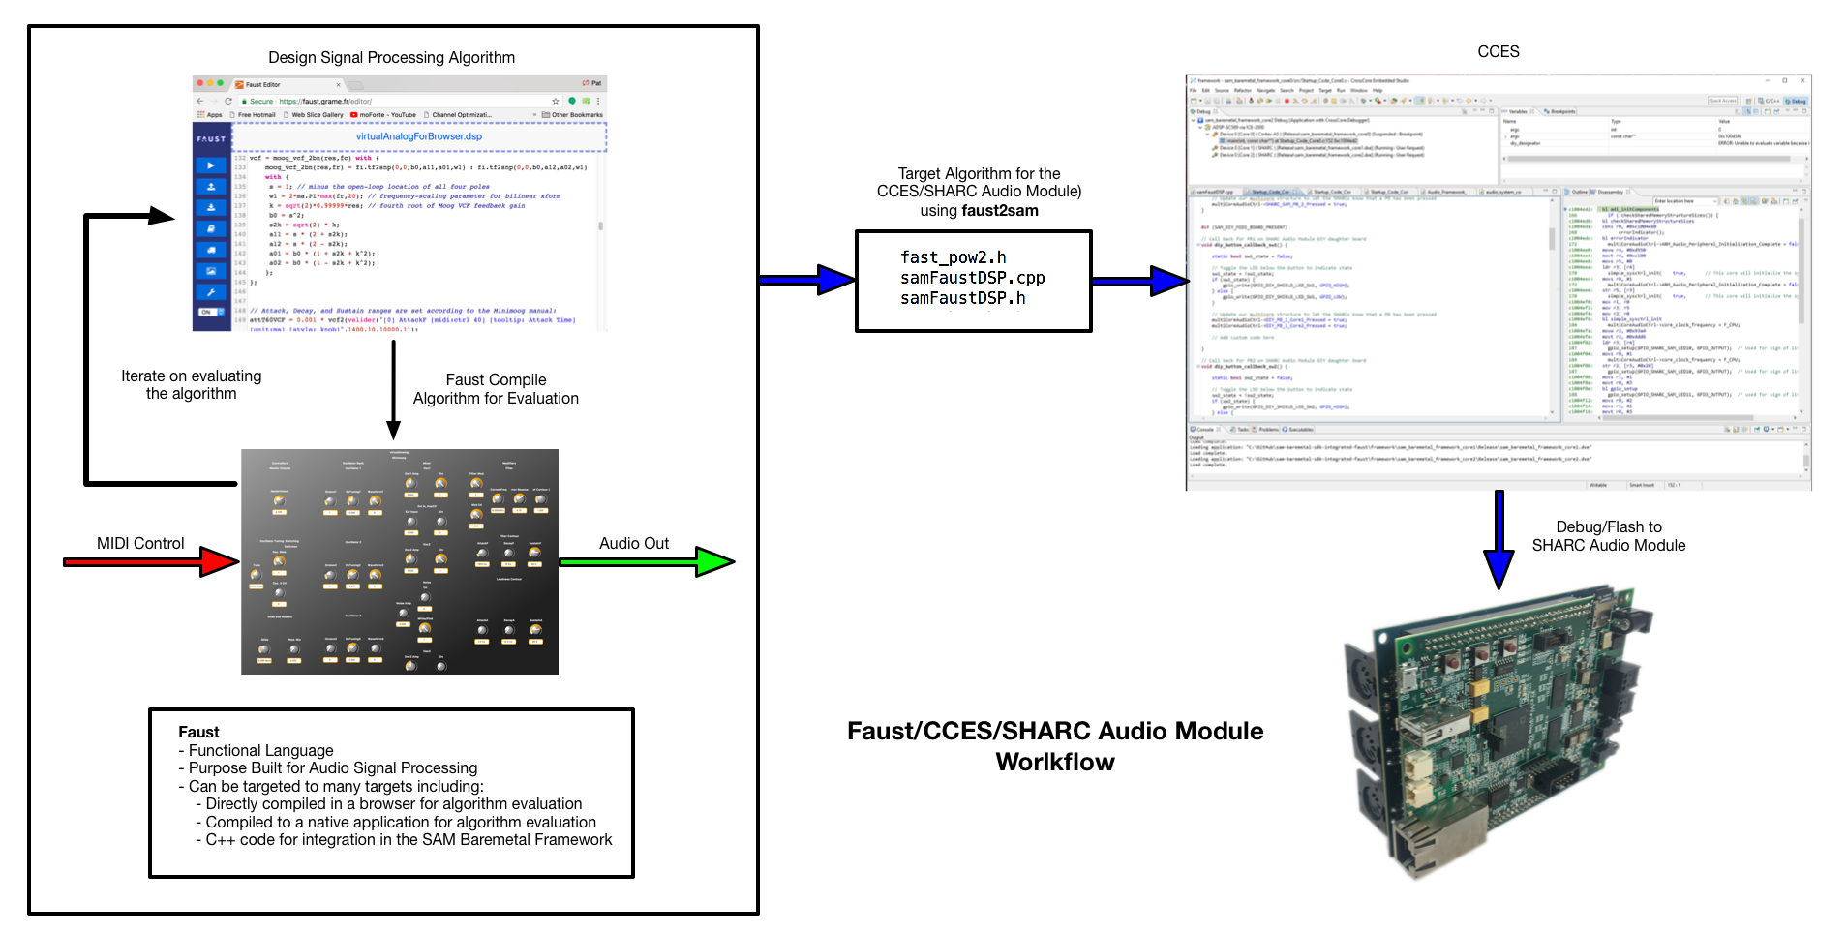

* Edit the Faust code using a text editor
* Use the **faust2caqt** program: to compile the code into a working host based application that supports both MIDI and Audio. This application can be used to experiment with the algorithm. Note that this compile can be up to 20 times faster than compiling with CCES. Thus, this host based application can be used to quickly experiment and make changes to the algorithm.
* Iterate on making changes to the algorithm.
* When the algorithm is mature, it can be migrated to CCES for compilation for the SHARC Audio Module. This migration is accomplished with the **faust2sam** script. The **faust2sam** script generates the following three C++ source files, which is the algorithm.   
    
  fast\_pow2.h  
  samFaustDSP.cpp  
  samFaustDSP.h
* CCES can then be used to compile and test the algorithm on the SHARC Audio Module.

Here is a block diagram of how the code for the virtual analog synthesizer demo and the effects chain is organized.

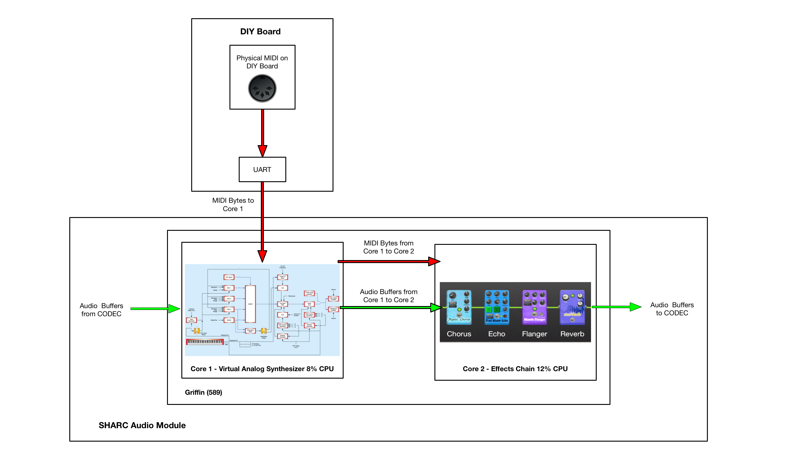

# Example Workflow – MIDI Controlled Volume on Core 1

A first example to demonstrate the workflow is a simple MIDI controlled stereo volume control that runs on Core 1.

## The Faust Code for the MIDI Controlled Volume

Here is the Faust code for the MIDI controlled stereo volume. Note that the metadata string “[midi:ctrl 2]” is used to map MIDI continuous controller 2 (CC-2) to control the gain slider.

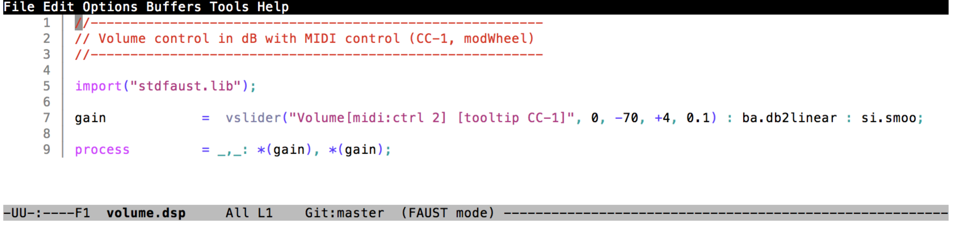

## Building a Test GUI for the MIDI Controlled Volume

A test GUI for this Faust program can be built with the **faust2caqt** program:

% faust2caqt –midi volume.dsp

% open volume.app

Here is what this test GUI looks like. This test program supports audio in/out and MIDI in/out and can be used to test the algorithm before committing to a SHARC Audio Module build.

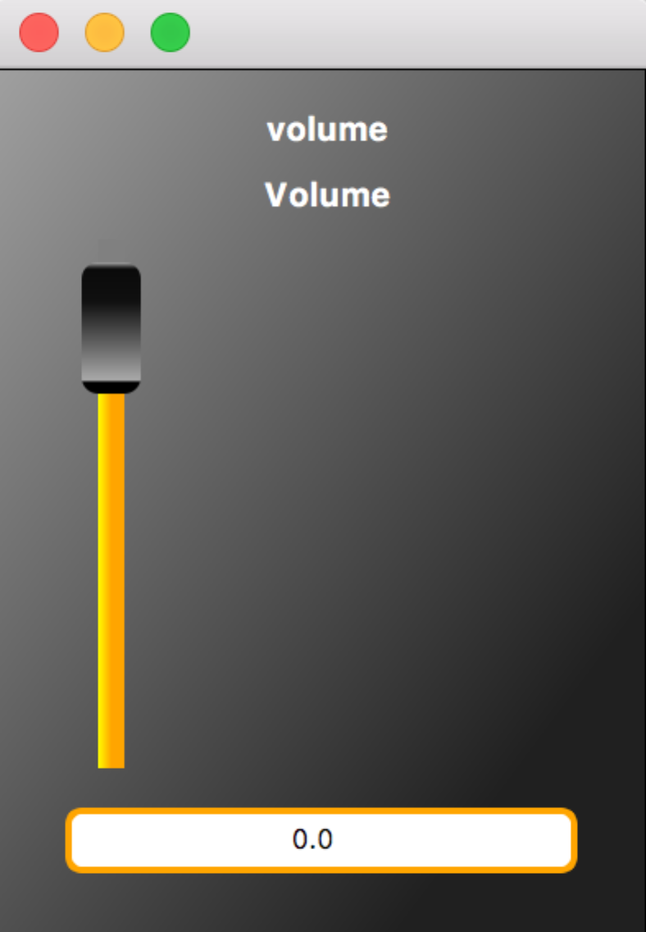

## Looking at the Block Diagram for the MIDI Controlled Volume

The **faust2firefox** command can be used to generate a hierarchical block diagram for an algorithm.

% faust2firefox volume.dsp

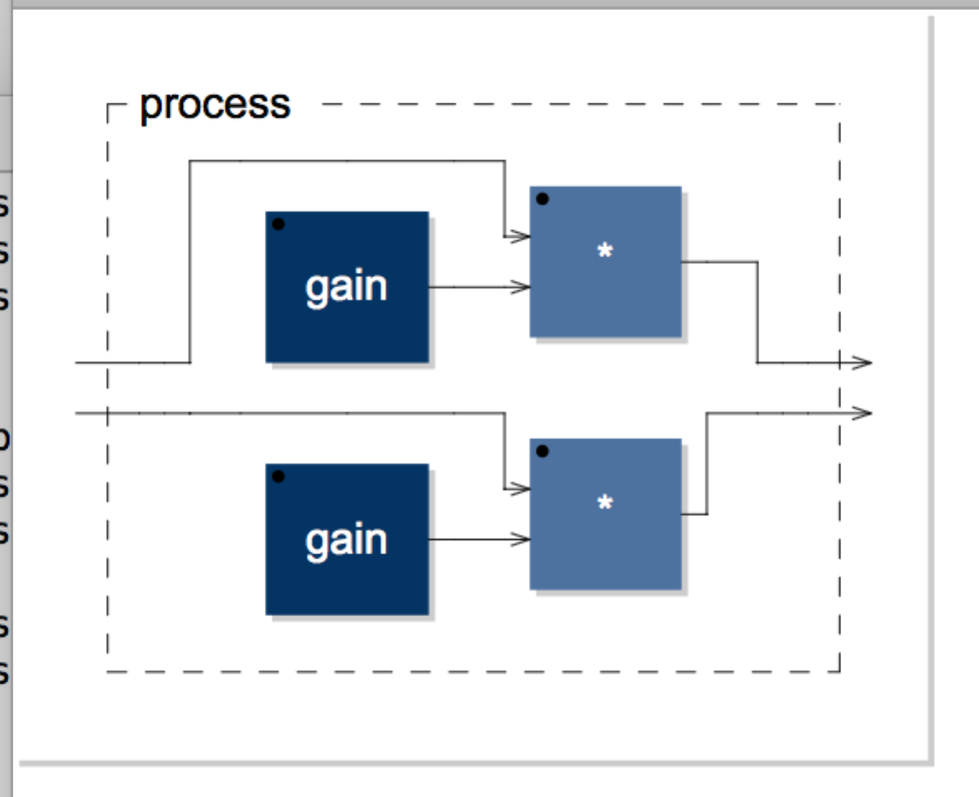

## Running faust2sam

**faust2sam** can be run as follows:

% faust2sam –midi volume.dsp

% open \*.zip

**faust2sam** will generate the following three C++ source files, which is the algorithm.

fast\_pow2.h

samFaustDSP.cpp

samFaustDSP.h

## The CCES Baremetal Framework

The CCES Baremetal Framework has a subproject directory for each DSP core:

sam\_baremetal\_framework\_Core1

sam\_baremetal\_framework\_Core2

For each project directory there is a directory where these three source files should be placed. Note that each core can be running a different Faust algorithm.

sam\_baremetal\_framework\_Core1/src/faust

sam\_baremetal\_framework\_Core2/src/faust

In addition there is a header file that is common across all cores called **audio\_system\_config.h.** In this file the following pre-processor variables should be set in the following way. The example below indicates that a Faust algorithm will only be running on Core1 and that Core2 will be simply passing audio to the codec.

#define SAM\_DIY\_MIDI\_BOARD\_PRESENT TRUE

…

#define FAUST\_INSTALLED TRUE

…

#define USE\_FAUST\_ALGORITHM\_CORE1 TRUE

#define USE\_FAUST\_ALGORITHM\_CORE2 FALSE

## Brief Notes on Compiling and Running the Algorithm in CCES

This document will **not** go into extensive detail on how to use CCES. However here are some brief notes on how to work with this algorithm.

* Copy the Faust C++ source files to the “faust” directory for the core that the algorithm will run on.
* Set the **audio\_system\_config**.**h** preprocessor variables as described.
* Open the workspace with CCES.
* Use “File> Import> General> Existing Projects into Workspace” to import the projects for each core into the workspace.
* Compile with “Project> Clean…”
* Run the project on the SHARC Audio Module. Be sure that the host computer is connected to the SHARC Audio Module with an ICE-2000 interface.
* Create a Debug Configuration per the CCES instructions.
* Run the compiled algorithm on the SHARC Audio Module with Run> Debug
  + Connect a MIDI controller to the DIY board MIDI In connector
  + Connect an audio source to line-in and a speaker to line-out
  + Send MIDI continuous controller 2. The volume of the audio source should range from silent to max volume in a linear fashion.

# Example Workflow – MIDI Controlled Reverb on Core 1

This second example is a MIDI controlled reverb on Core 1.

## The Faust Code for the MIDI Controlled Reverb

Here is a subset the Faust code for the MIDI controlled reverb.

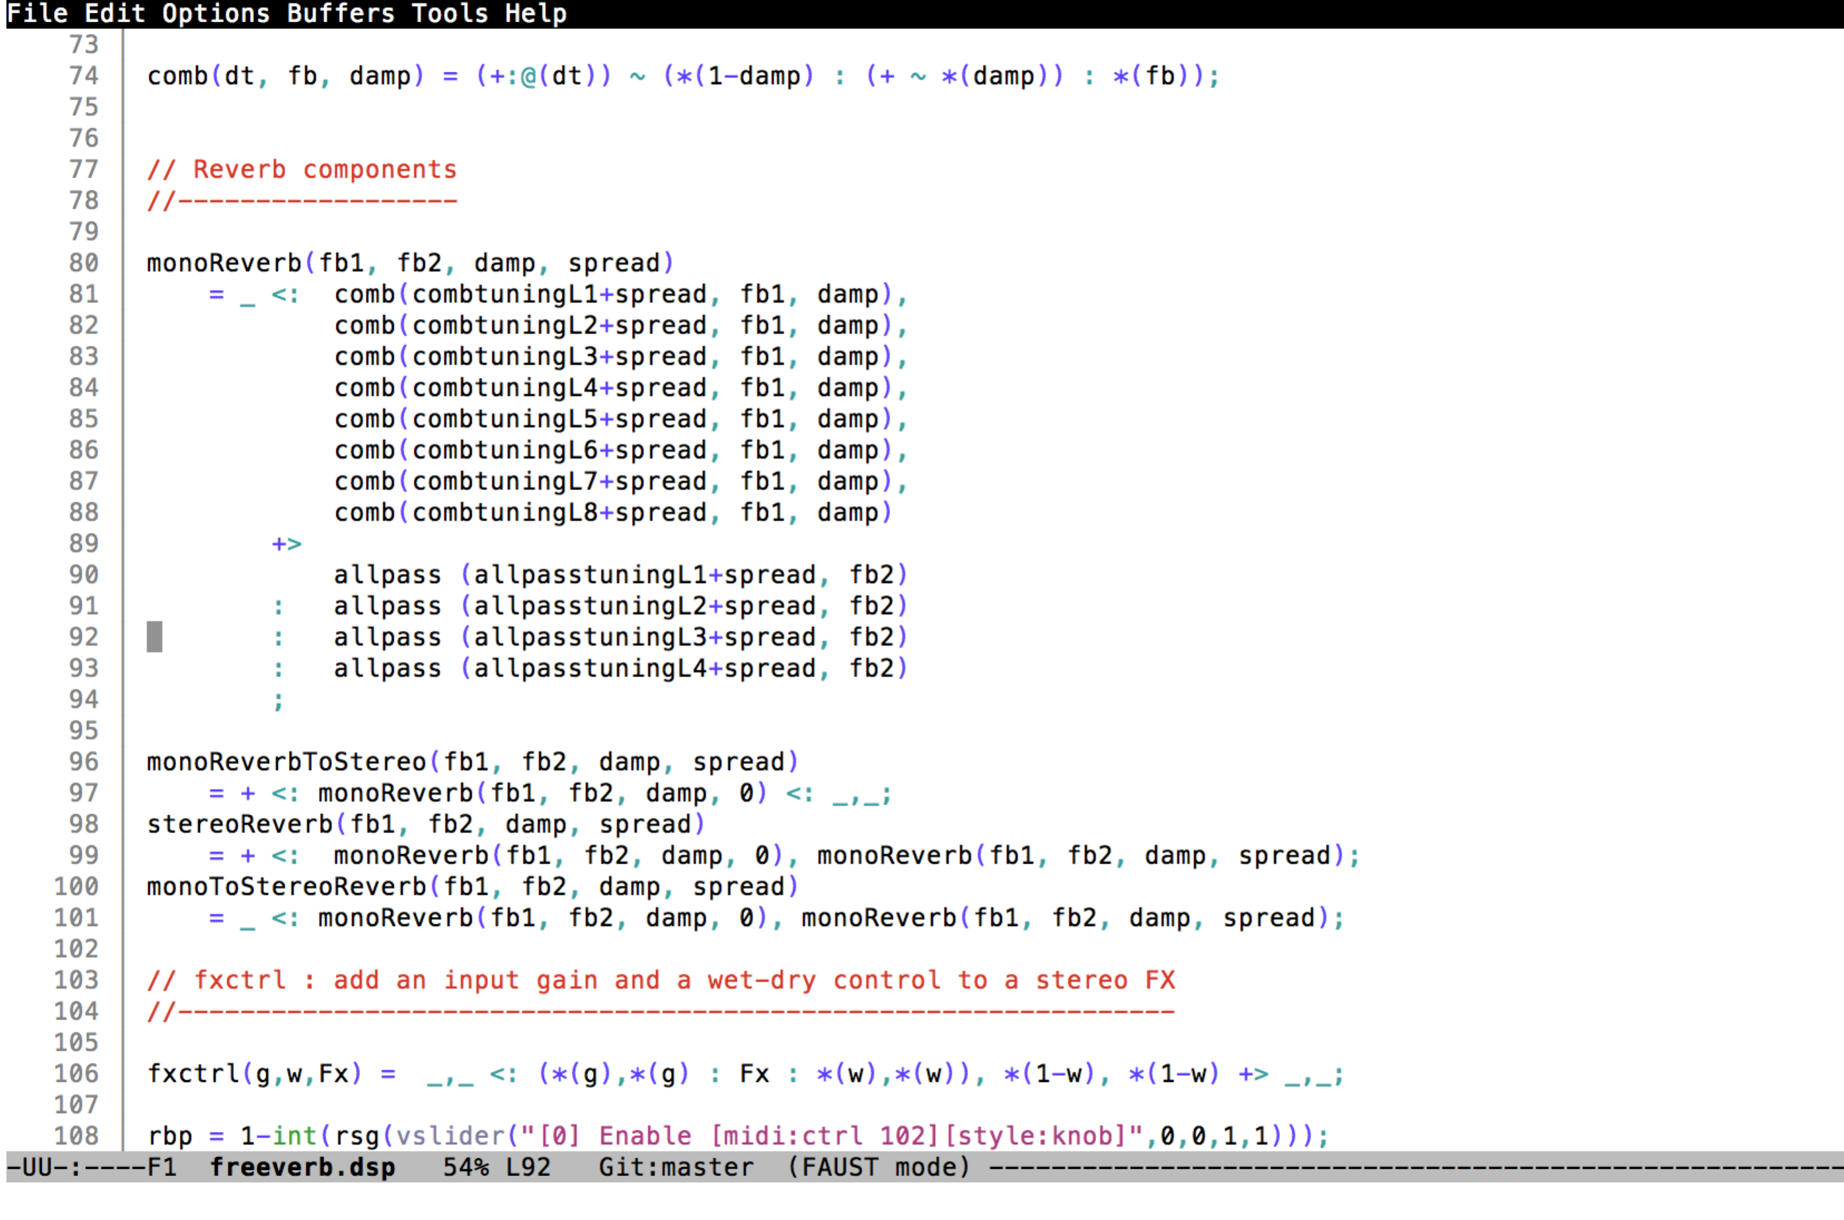

## Building a Test GUI for the MIDI Controlled Reverb

A test GUI for this Faust program can be built with the **faust2caqt** program:

% faust2caqt –midi freeverb.dsp

% open freeverb.app

Here is what this test GUI looks like. This test program supports audio in/out and MIDI in/out and can be used to test the algorithm before committing to a SHARC Audio Module build.

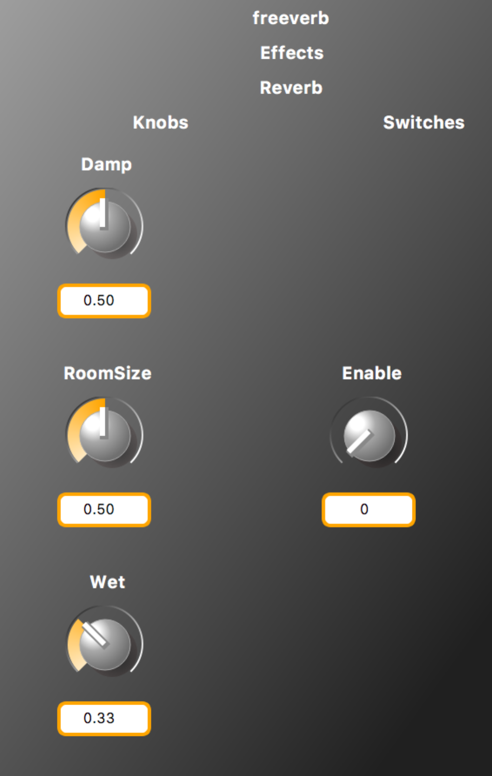

## Looking at the Block Diagram for the MIDI Controlled Reverb

The **faust2firefox** command can be used to generate a block diagram for an algorithm. This block diagram is hierarchical. Here are a few of the hierarchical levels:

% faust2firefox freeverb.dsp

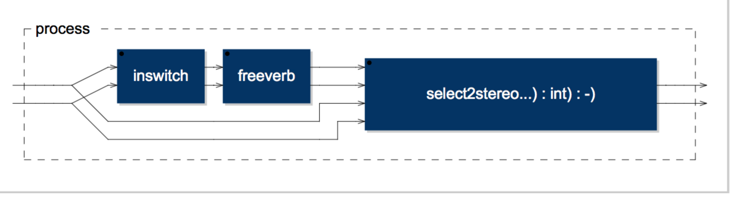

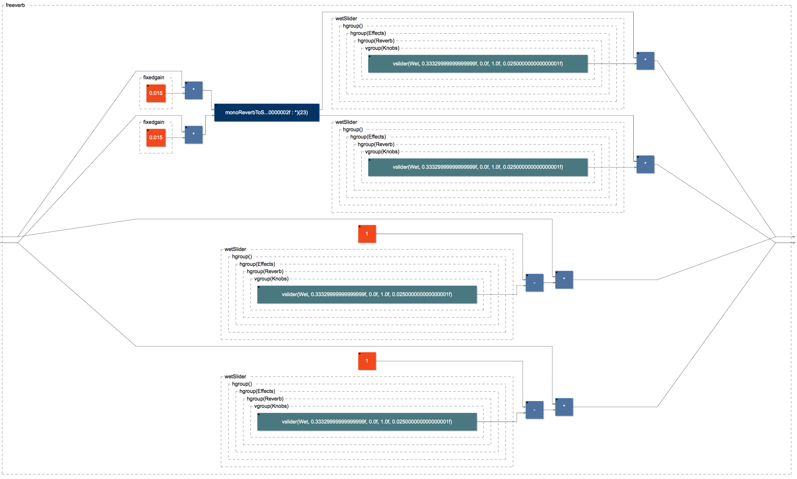

## Running faust2sam

**faust2sam** can be run as follows:

% faust2sam –midi freeverb.dsp

% open \*.zip

**faust2sam** will generate the following three C++ source files, which is the algorithm.

fast\_pow2.h

samFaustDSP.cpp

samFaustDSP.h

# Example Workflow – MIDI Sawtooth Synth (Core 1)

This third example is a MIDI controlled sawtooth synth on Core 1.

## The Faust Code for the MIDI Controlled Sawtooth Synth

Here is the Faust code for the MIDI controlled sawtooth synth. Notice the use of the metadata elements:

* freq – If a MIDI noteOn event is received it’s MIDI keyNumber is mapped to a frequency.
* bend – if a MIDI pitchBend message is received it is mapped to a bend value.
* gain – if a MIDI noteOn message is received it’s velocity value is mapped to a gain value which ranges from [0 .. 1.0]
* gate – if MIDI noteOn/noteOff messages are received they are mapped to a gate value (0/1)
* [midi:ctrl 1] – A Faust control (slider, etc) can be mapped to listen to a MIDI continuous controller.



## Building a Test GUI for the MIDI Controlled Sawtooth Synth

A test GUI for this Faust program can be built with the **faust2caqt** program:

% faust2caqt –midi –nvoices 6 sawtooth\_synth.dsp

% open sawtooth\_synth.app

Here is what this test GUI looks like. This test program supports audio in/out and MIDI in/out and can be used to test the algorithm before committing to a SHARC Audio Module build.

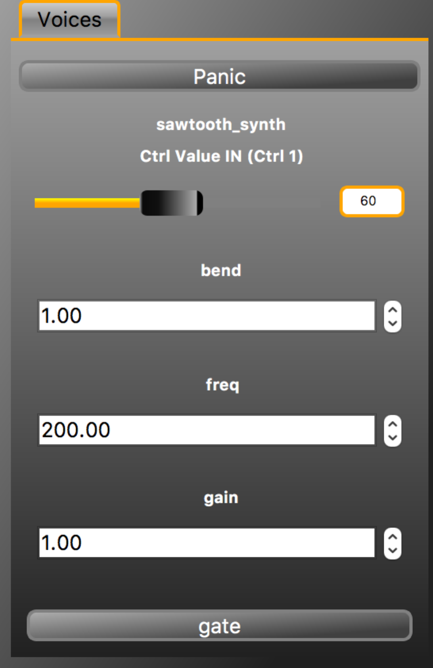

## Looking at the Block Diagram for the MIDI Controlled Sawtooth

The **faust2firefox** command can be used to generate a hierarchical block diagram for an algorithm. This block diagram is hierarchical. Here are a few of the hierarchical levels:

% faust2firefox sawtooth\_synth.dsp

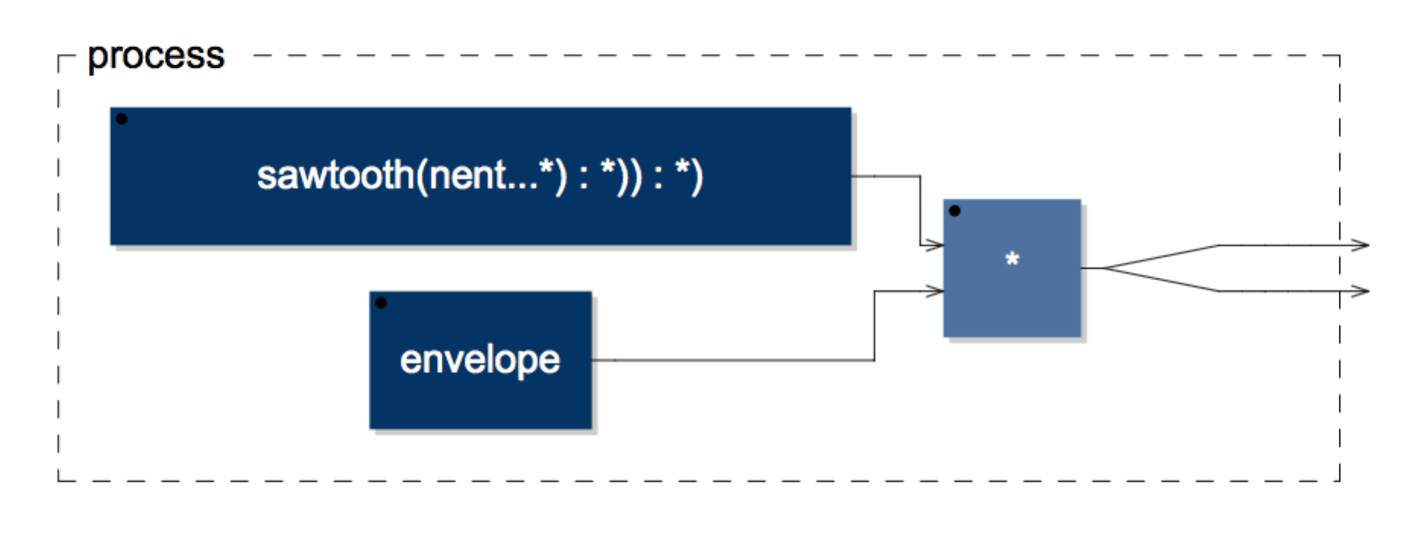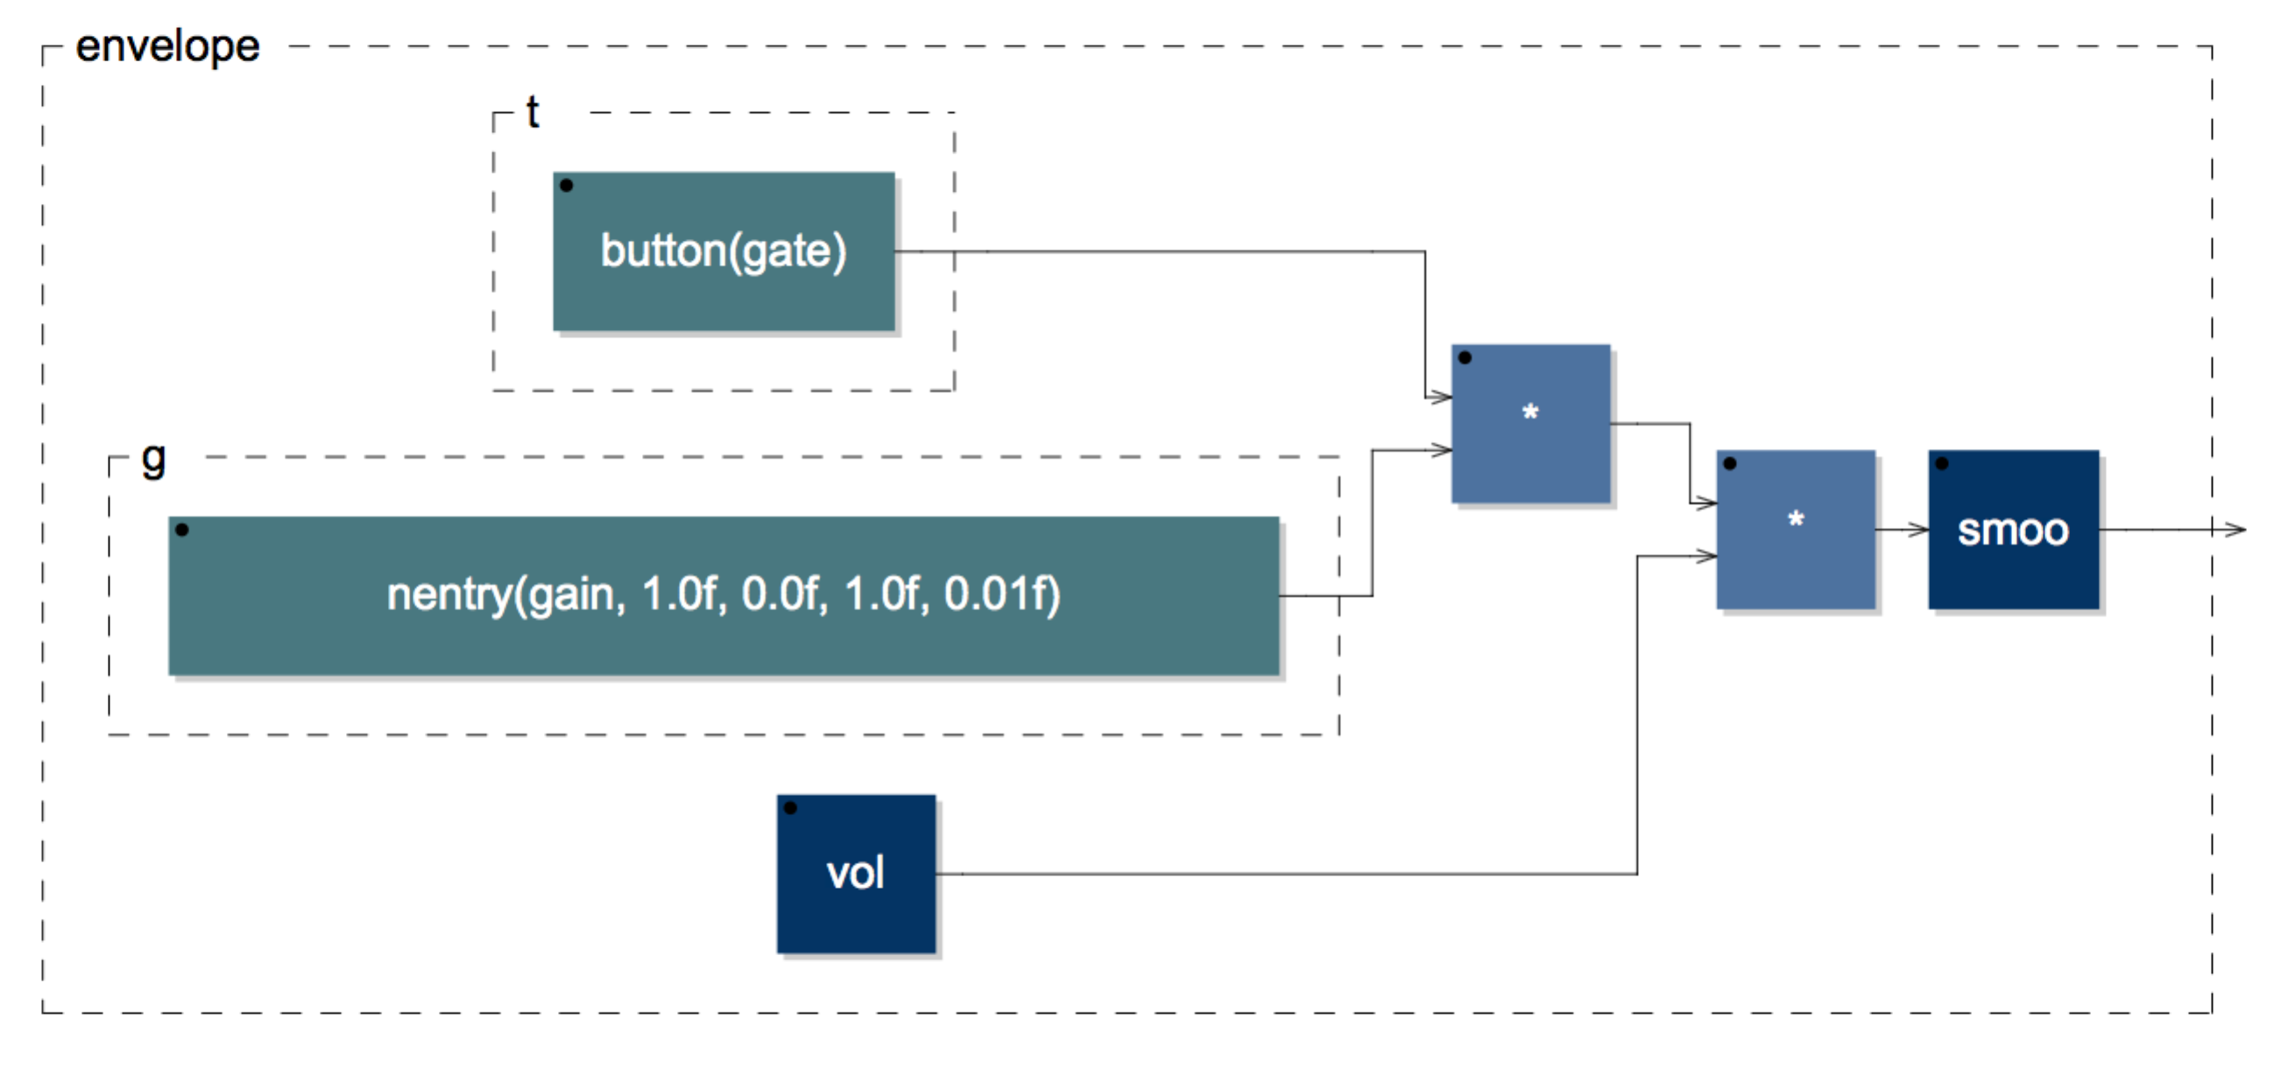

## Running faust2sam

**faust2sam** can be run as follows:

% faust2sam –midi –nvoices 6 sawtooth\_synth.dsp

% open \*.zip

**faust2sam** will generate the following three C++ source files, which is the algorithm.

fast\_pow2.h

samFaustDSP.cpp

samFaustDSP.h

# Example Workflow – MIDI Virtual Analog Synth (Core1) /Effects (Core 2)

For this final example the full virtual analog synth is run on Core1 and the effects chain is run on Core 2.

## The Faust Code for the Virtual Analog Synth (Core 1)

Here is a subset of the Faust code for the virtual analog synth:

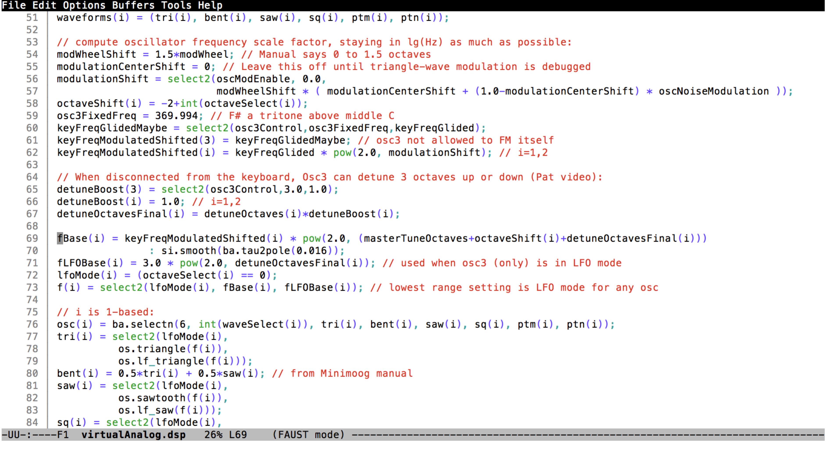

## Building a Test GUI for the Virtual Analog Synth

A test GUI for this Faust program can be built with the **faust2caqt** program:

% faust2caqt –midi –nvoices 1 virtualAnalog.dsp

% open virtualAnalog.app

Here is what this test GUI looks like. This test program supports audio in/out and MIDI in/out and can be used to test the algorithm before committing to a SHARC Audio Module build.

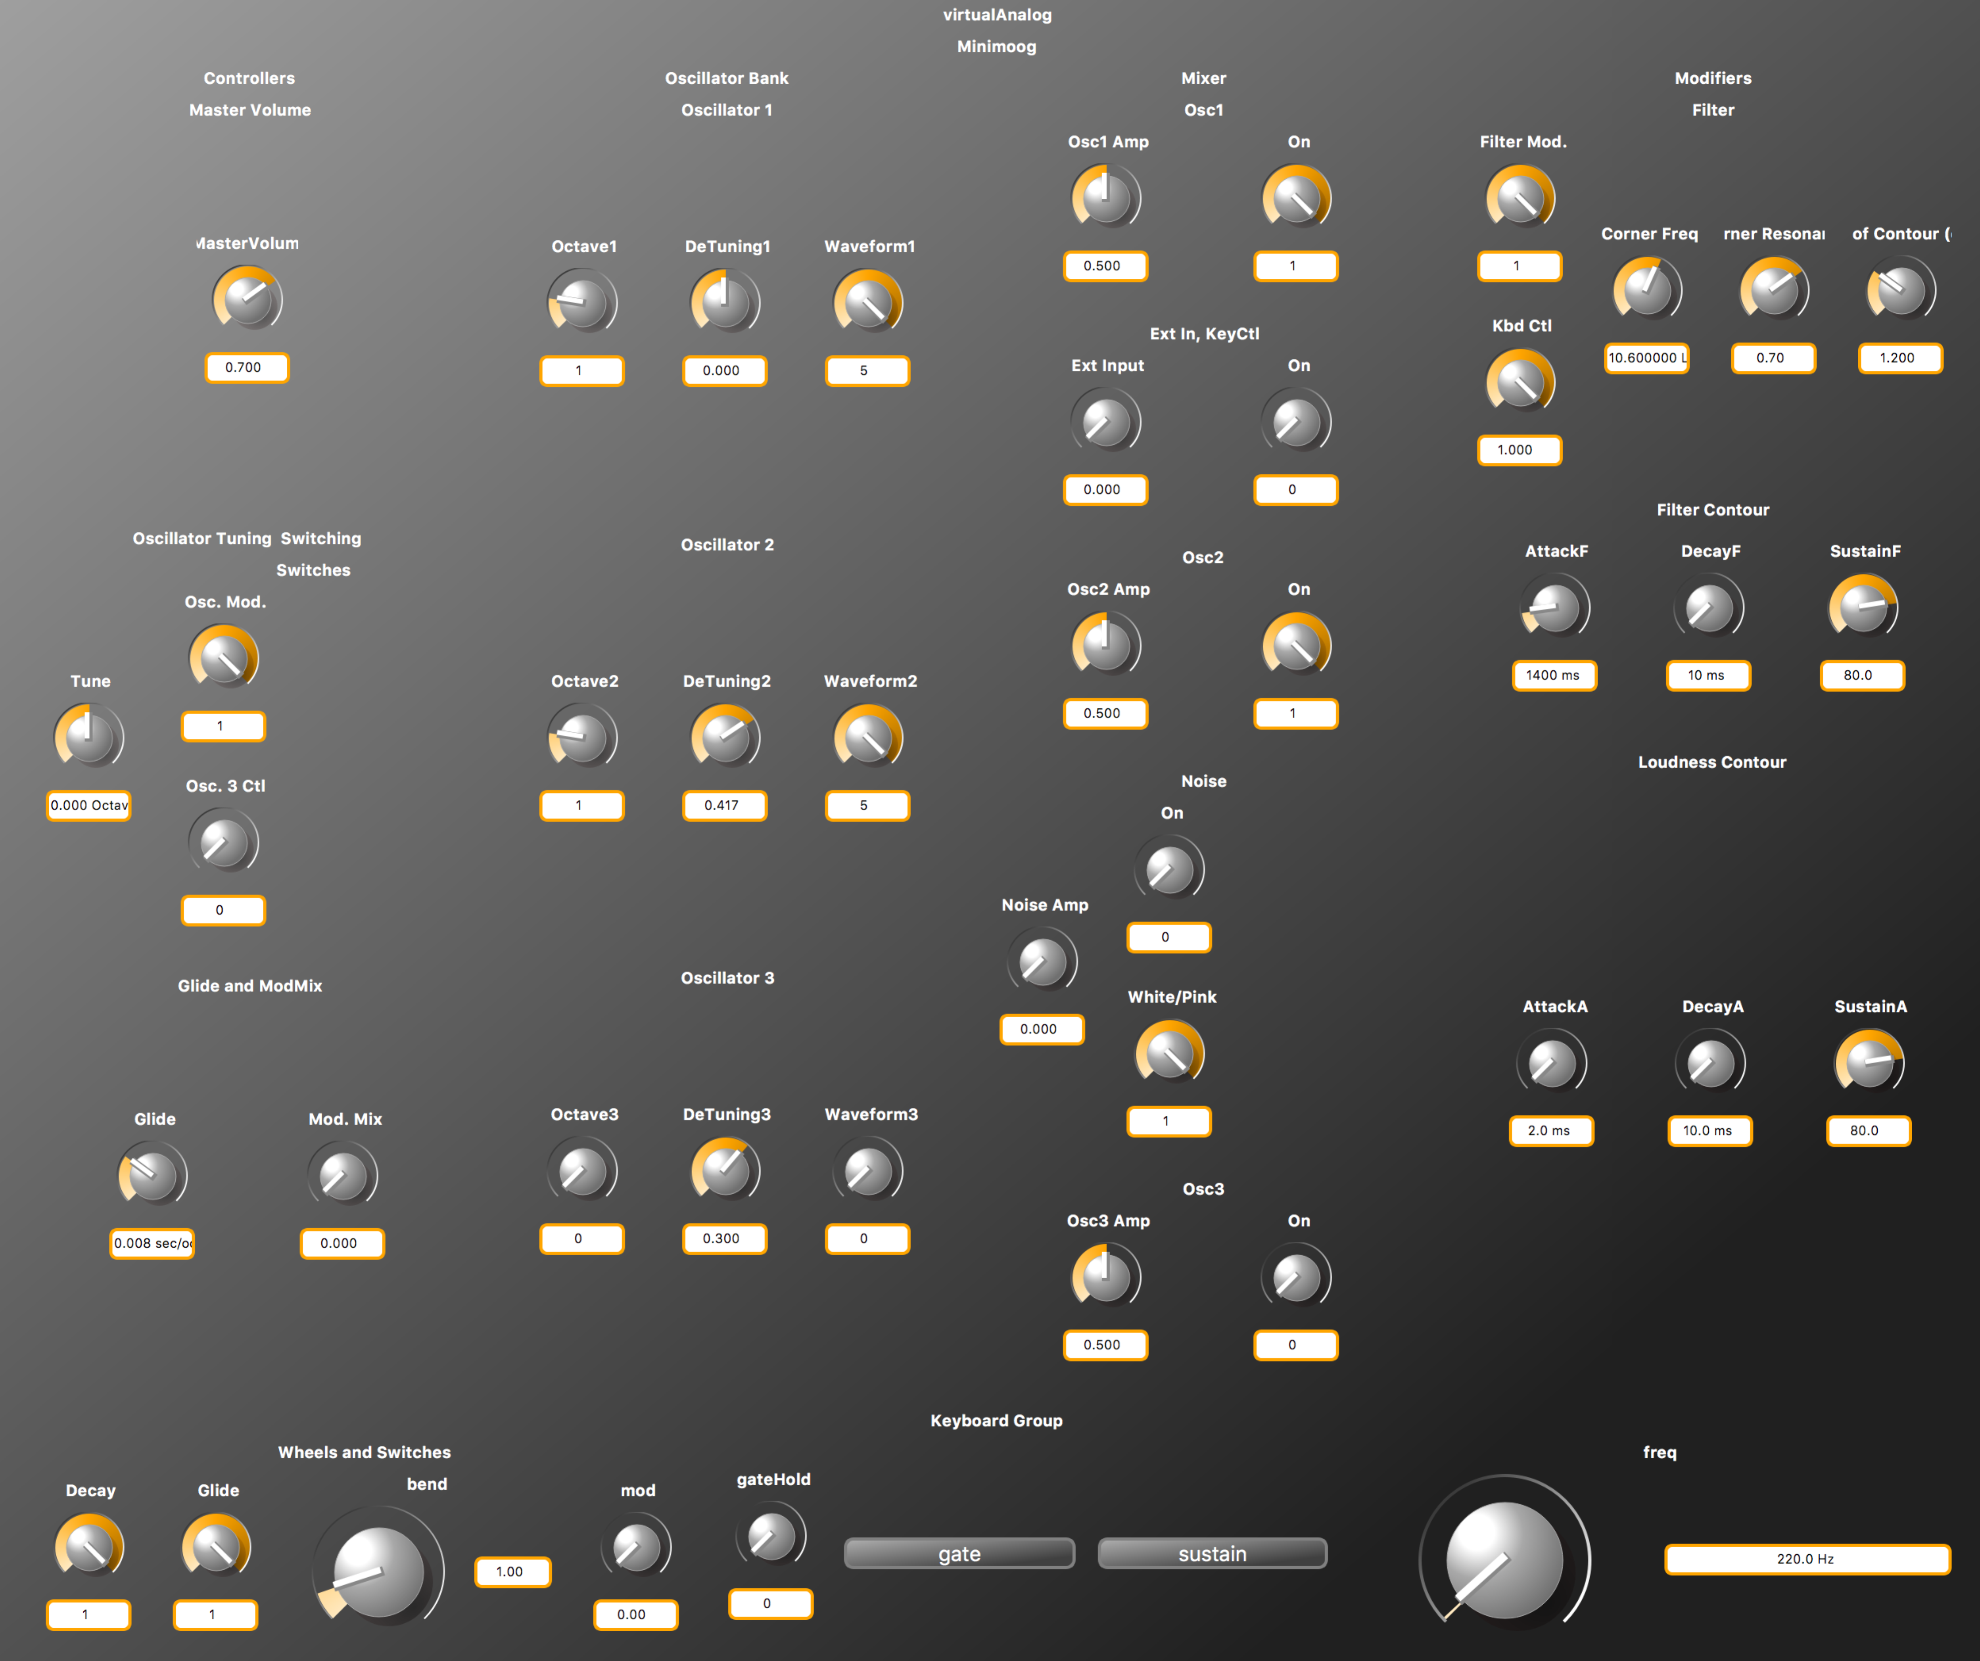

## Looking at the Block Diagram for the Virtual Analog Synth

The **faust2firefox** command can be used to generate a hierarchical block diagram for an algorithm. This block diagram is hierarchical. Here are a few of the hierarchical levels:

% faust2firefox virtualAnalog.dsp

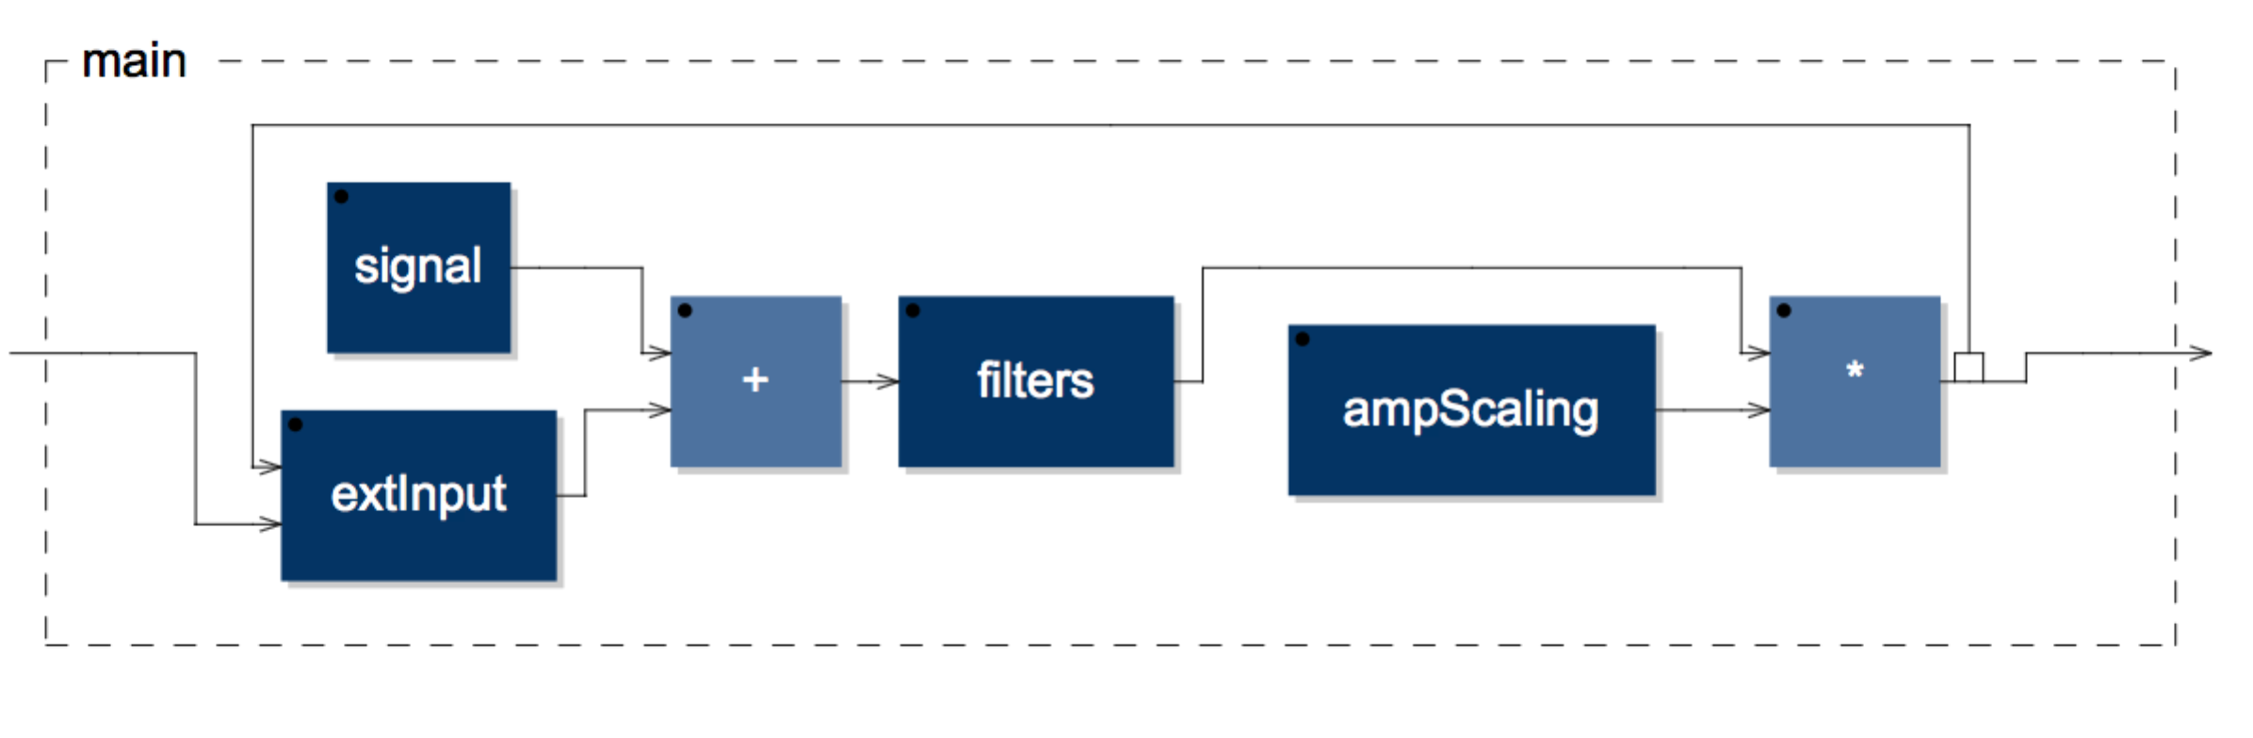

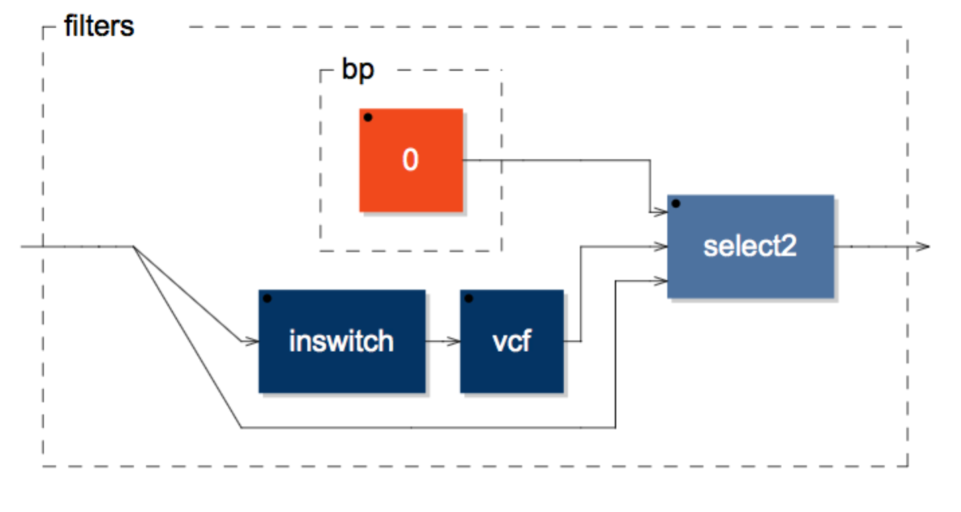

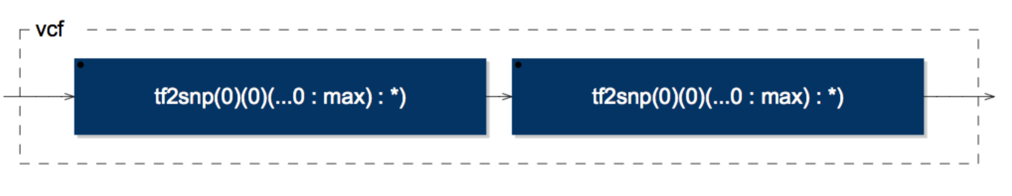

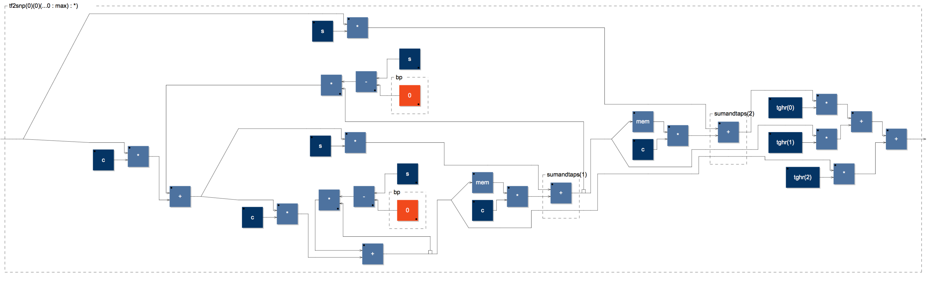

## Running faust2sam

**faust2sam** can be run as follows:

% faust2sam –midi –nvoices 1 virtualAnalog.dsp

% open \*.zip

**faust2sam** will generate the following three C++ source files, which is the algorithm.

fast\_pow2.h

samFaustDSP.cpp

samFaustDSP.h

## The Faust Code for the Effects Chain (Core 2)

The effects chain (echo: flanger: chorus: reverb) is run on Core 2.

Here is a subset of the Faust code for the effects chain (echo: flanger: chorus: reverb).

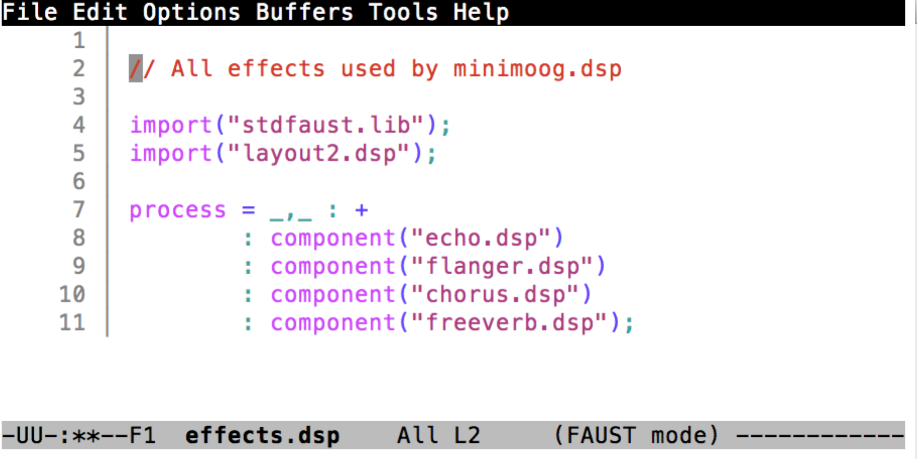

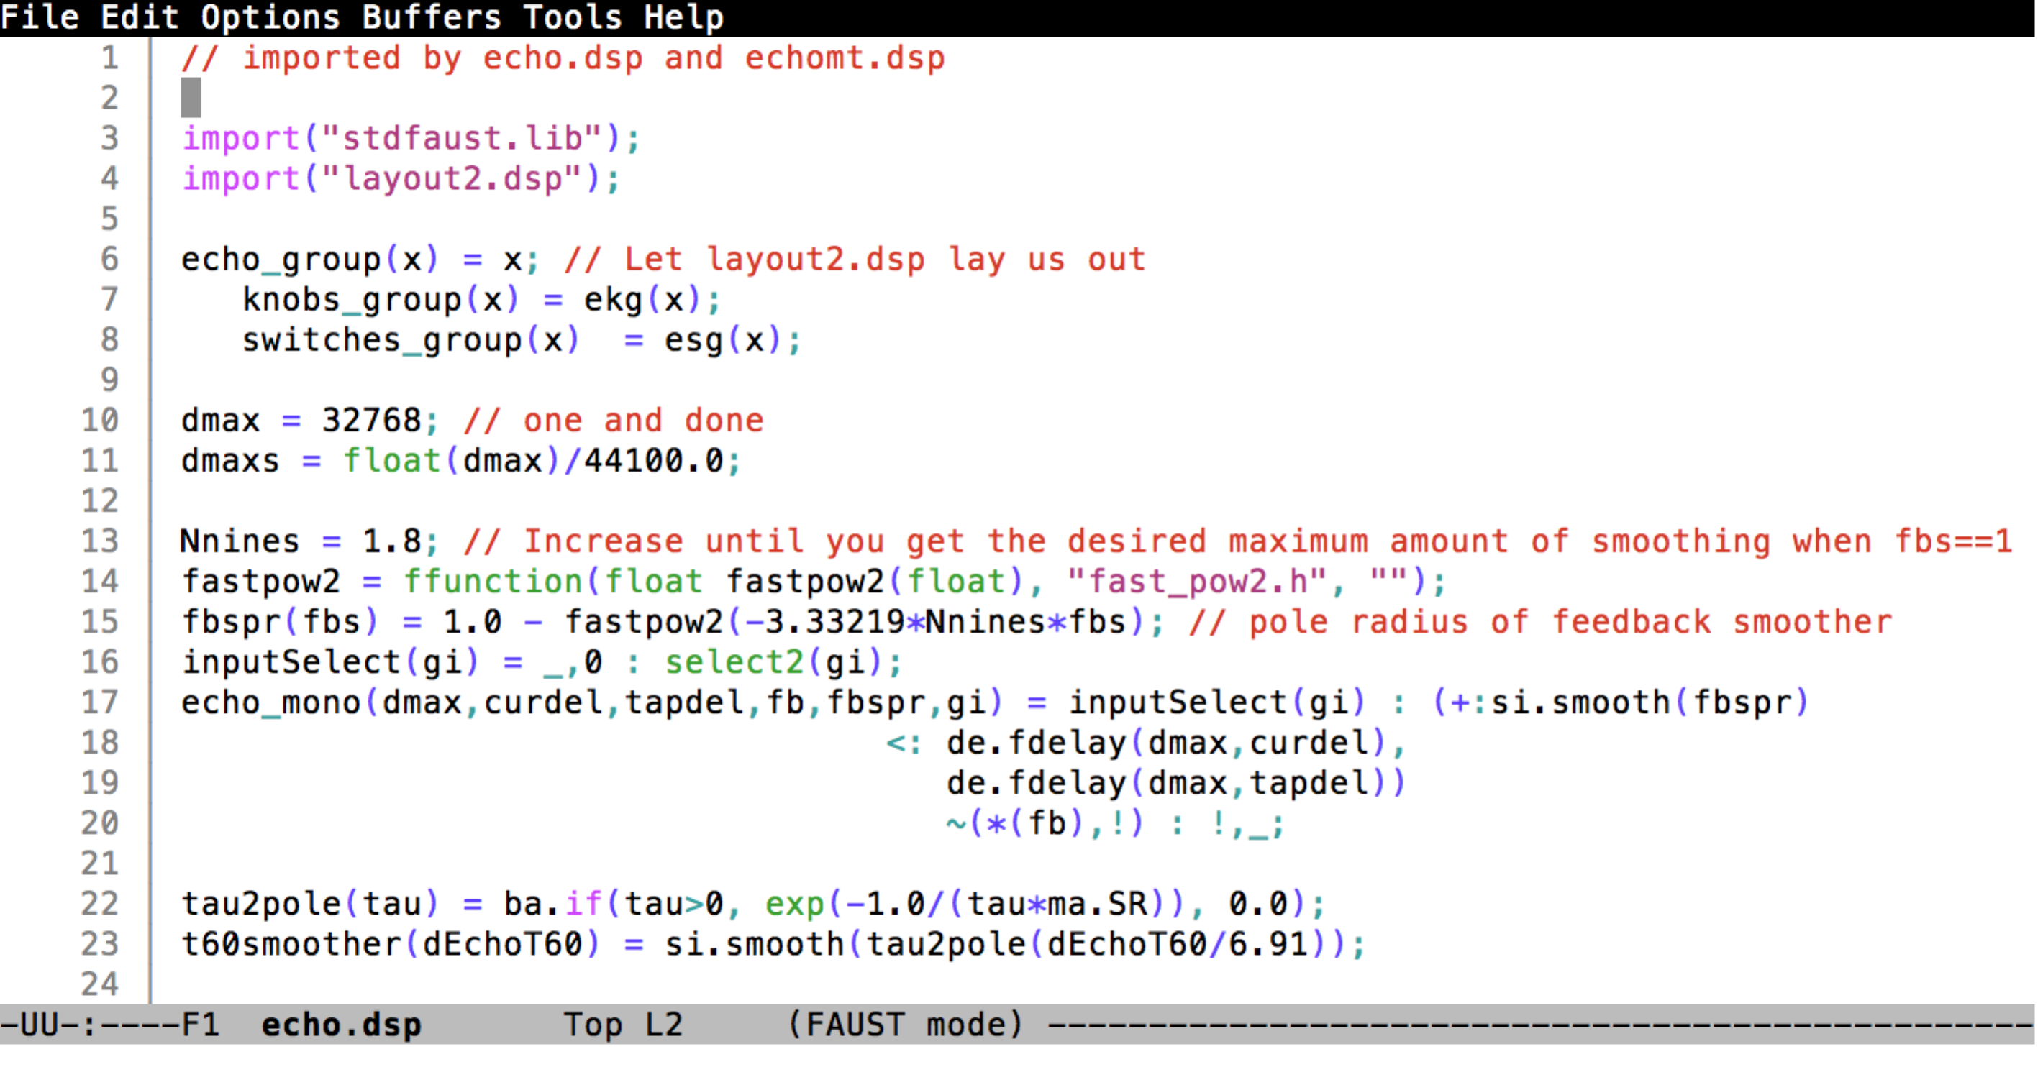

## Building a Test GUI for the Effects Chain

A test GUI for this Faust program can be built with the **faust2caqt** program:

% faust2caqt –midi effects.dsp

% open effects.app

Here is what this test GUI looks like. This test program supports audio in/out and MIDI in/out and can be used to test the algorithm before committing to a SHARC Audio Module build.

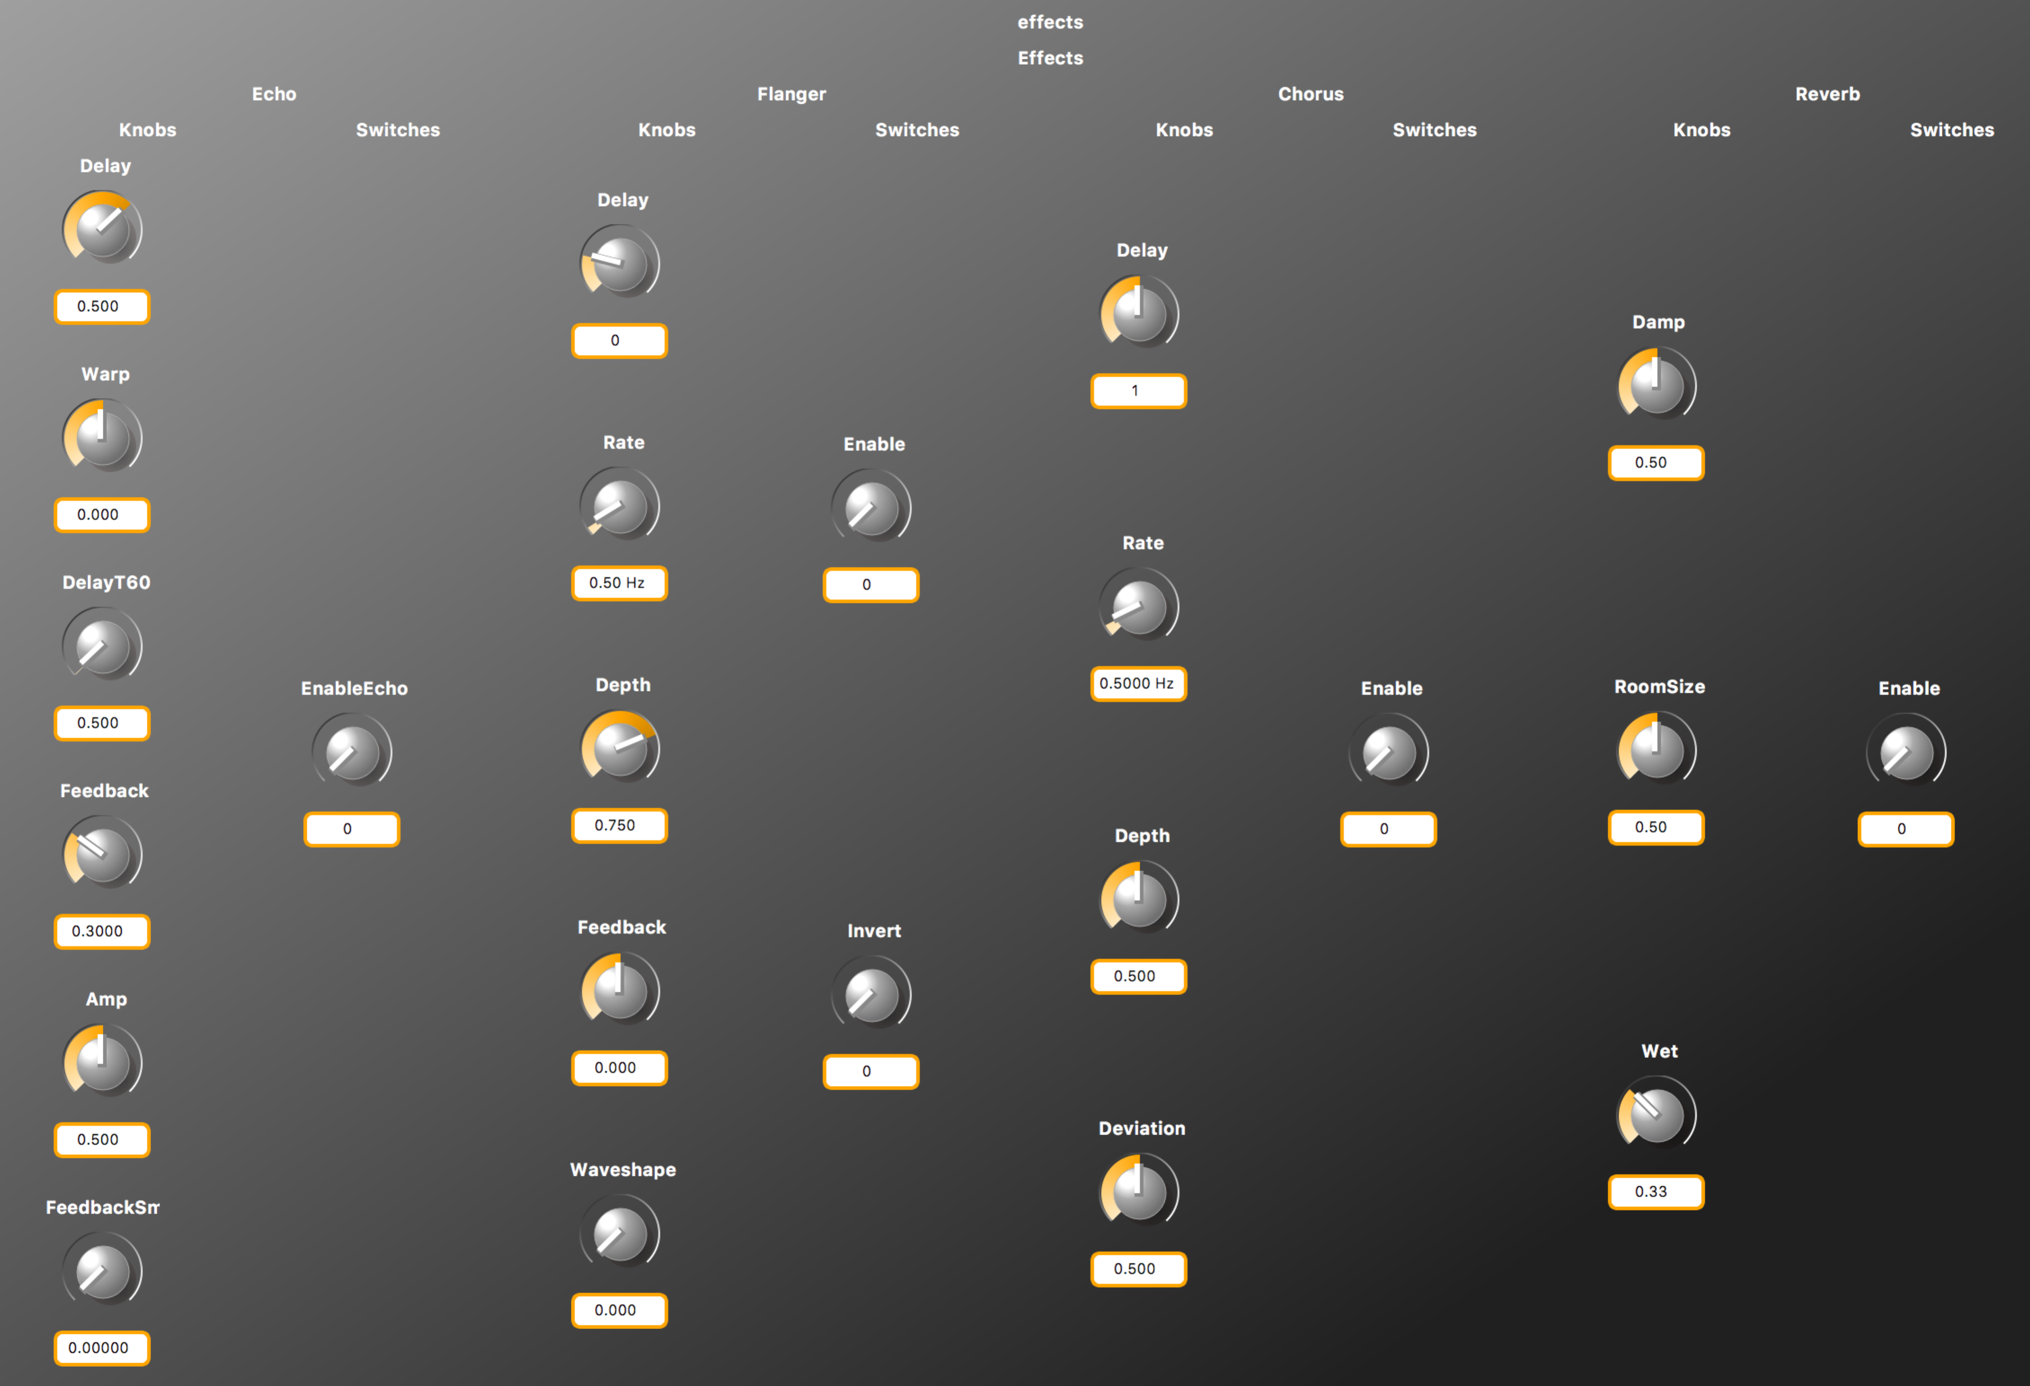

## Looking at the Block Diagram for the Effects Chain

The **faust2firefox** command can be used to generate a hierarchical block diagram for an algorithm. This block diagram is hierarchical. Here are a few of the hierarchical levels:

% faust2firefox effects.dsp

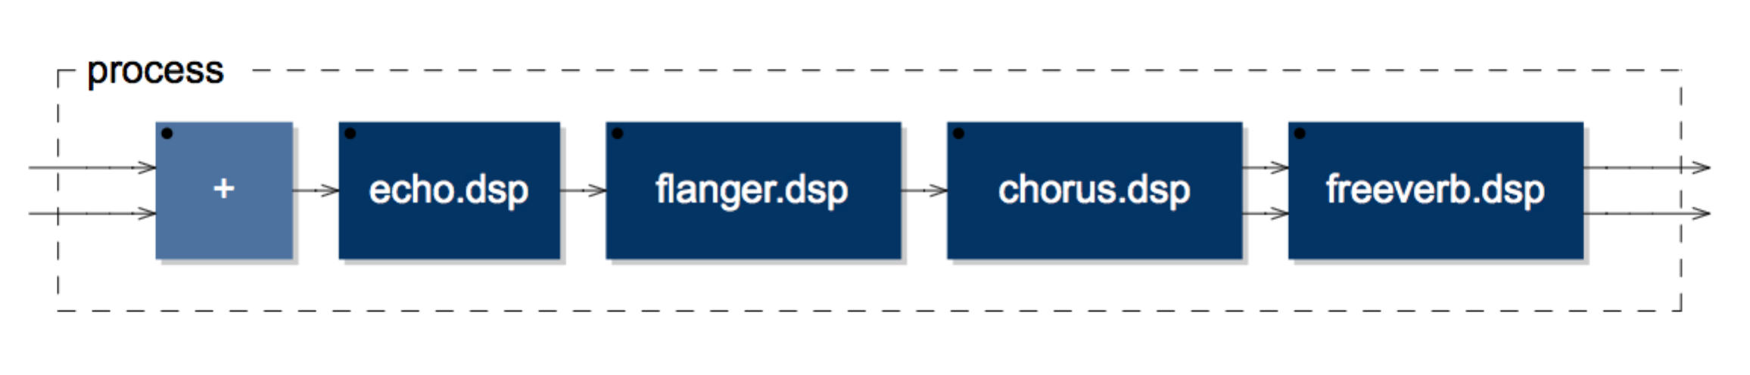

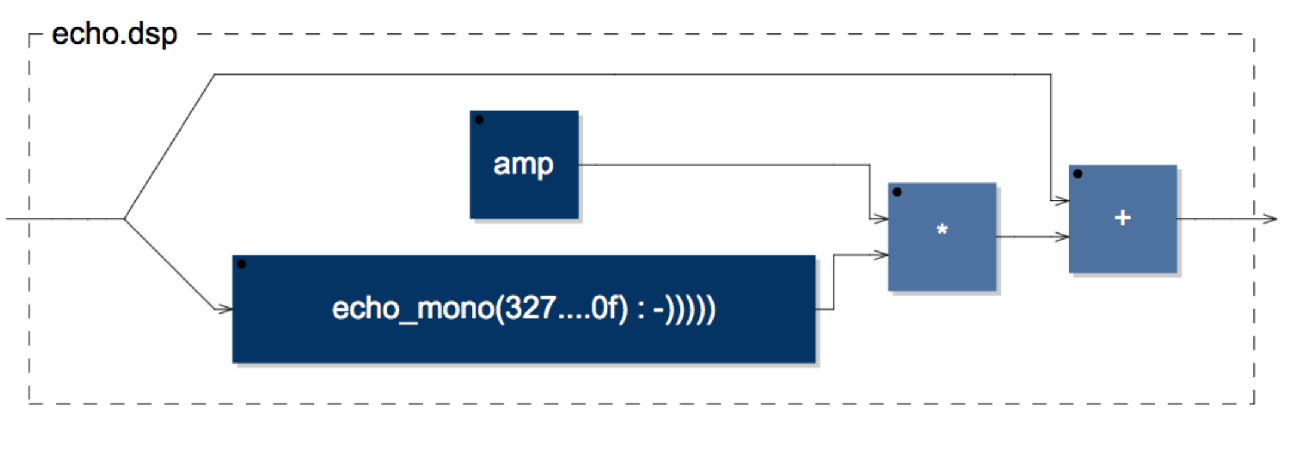

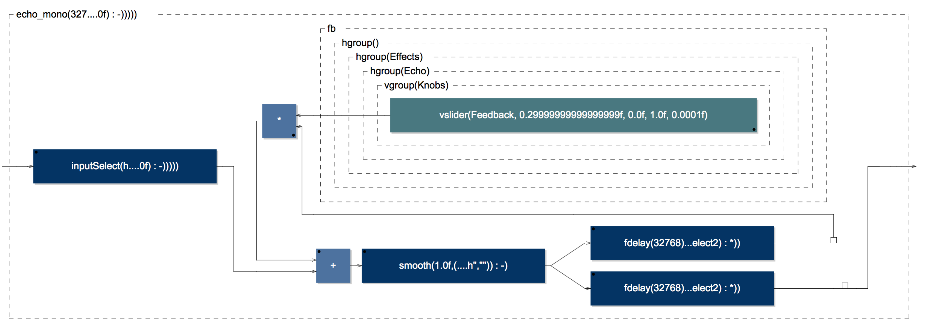

## Running faust2sam

**faust2sam** can be run as follows:

% faust2sam –midi effects.dsp

% open \*.zip

**faust2sam** will generate the following three C++ source files, which is the algorithm.

fast\_pow2.h

samFaustDSP.cpp

samFaustDSP.h

## The CCES Baremetal Framework

The CCES Baremetal Framework has a subproject directory for each DSP core:

sam\_baremetal\_framework\_Core1/src/faust

sam\_baremetal\_framework\_Core2/src/faust

The virtualAnalog C++ files should be placed in the “faust” directory for Core 1 and the effects chain C++ files should be placed in the “faust” directory for Core 2.

In **audio\_system\_config.h.** In this file the following pre-processor variables should be set. This indicates that Faust algorithms will be running on Core1 **and** Core2.

#define SAM\_DIY\_MIDI\_BOARD\_PRESENT TRUE

…

#define FAUST\_INSTALLED TRUE

…

#define USE\_FAUST\_ALGORITHM\_CORE1 TRUE

#define USE\_FAUST\_ALGORITHM\_CORE2 FALSE

## MIDI Assignments for the Virtual Analog Algorithm

|  |  |  |  |  |
| --- | --- | --- | --- | --- |
| **Function** | **MIDI CC** | **Module** | **Type** | **Notes** |
| Tune | 47 | 1 - Controllers | knob | Master tuning |
| Glide | 5 | 1 - Controllers | knob | Portamento time |
| Modulation Mix | 48 | 1 - Controllers | knob | Modulation mix between OSC3 and Noise |
|  |  |  |  |  |
| Oscillator Modulation | 22 | 2 - Oscillator Bank | switch | Enable modulation control of OSC frequencies |
| OSC 1 Range | 23 | 2 - Oscillator Bank | knob | OSC 1 range |
| OSC 1 Detune | 24 | 2 - Oscillator Bank | knob | OSC 1 detuning |
| OSC 1 Waveform | 25 | 2 - Oscillator Bank | knob | OSC 1 waveform shape |
| OSC 2 Range | 28 | 2 - Oscillator Bank | knob | OSC 2 range |
| OSC 2 Detune | 29 | 2 - Oscillator Bank | knob | OSC 2 detuning |
| OSC 2 Waveform | 30 | 2 - Oscillator Bank | knob | OSC 2 waveform shape |
| OSC 3 Range | 33 | 2 - Oscillator Bank | knob | OSC 3 range |
| OSC 3 Detune | 34 | 2 - Oscillator Bank | knob | OSC 3 detuning |
| OSC 3 Waveform | 35 | 2 - Oscillator Bank | knob | OSC 3 waveform shape |
| OSC 3 Control | 9 | 2 - Oscillator Bank | switch | OSC 3 as a control signal or as an audio source |
|  |  |  |  |  |
| OSC 1 Amp | 26 | 3 - Mixer | knob | OSC 1 gain |
| Osc1 mixer switch | 12 | 3 - Mixer | switch | OSC 1 enable |
| OSC 2 Amp | 31 | 3 - Mixer | knob | OSC 2 gain |
| Osc2 mixer switch | 14 | 3 - Mixer | switch | OSC 2 enable |
| OSC3 Amp | 36 | 3 - Mixer | knob | OSC 3 gain |
| OSC3 mixer switch | 17 | 3 - Mixer | switch | OSC 3 enable |
| External Input amp | 27 | 3 - Mixer | knob | Extrenal input gain |
| External Input mixer switch | 13 | 3 - Mixer | switch | External input enable |
| Noise Amp | 32 | 3 - Mixer | knob | Noise gain |
| Noise mixer switch | 15 | 3 - Mixer | switch | Noise Enable |
| White/pink toggle | 16 | 3 - Mixer | switch | Noise pink/white |

|  |  |  |  |  |
| --- | --- | --- | --- | --- |
| Filter Modulation Enable | 19 | 4 - Filter | switch | Enable modulation control of the filter cutoff frequency |
| Keyboard Range | 38 | 4 - Filter | knob | Add keyboard control of the filter cutoff frequency |
| Cutoff Frequency | 74 | 4 - Filter | knob | Filter cutoff frequency |
| Emphasis | 37 | 4 - Filter | knob | Filter Resonance (Q) |
| Amount of Contour | 39 | 4 - Filter | knob | Amount of envelope generator |
| Attack Time | 40 | 4 - Filter | knob | VCF envelope generator attack time |
| Decay Time | 41 | 4 - Filter | knob | VCF envelope generator decay time |
| Sustain Level | 42 | 4 - Filter | knob | VCF envelope generator sustain level |
|  |  |  |  |  |
| Attack Time | 43 | 5 - Loudness Contour | knob | VCA envelope generator attack time |
| Decay Time | 44 | 5 - Loudness Contour | knob | VCA envelope generator decay time |
| Sustain Level | 45 | 5 - Loudness Contour | knob | VCA envelope generator sustain level |
|  |  |  |  |  |
| Decay | 20 | 6 - Keyboard | switch | Enables using the decay stage as a release stage |
| Glide | 65 | 6 - Keyboard | switch | Enable portamento |
| Pitch Wheel | pitchWheel | 6 - Keyboard | knob | Pitch Wheel |
| Mod Wheel | 1 | 6 - Keyboard | knob | Modulation Wheel control |
| Sustain | 64 | midi sustain foot pedal | switch | Note sustain, preempts the VCF/VCA release stage |
|  |  |  |  |  |
| Master Volume | 7 | 5 - Output | knob | Master volume |

## MIDI Assignments for the Effects Chain Algorithm

|  |  |  |  |
| --- | --- | --- | --- |
| **Function** | **MIDI CC** | **Module** | **Type** |
|  |  |  |  |
| Invert | 49 | Flanger | knob |
| Enable | 102 | Flanger | switch |
| Delay | 50 | Flanger | knob |
| Rate | 51 | Flanger | knob |
| Depth | 52 | Flanger | knob |
| Feedback | 53 | Flanger | knob |
| Wave Shape | 54 | Flanger | knob |
|  |  |  |  |
| Delay | 55 | Chorus | knob |
| Enable | 103 | Chorus | switch |
| Rate | 56 | Chorus | knob |
| Depth | 57 | Chorus | knob |
| Deviation | 58 | Chorus | knob |
|  |  |  |  |
| enable | 105 | Echo | switch |
| Delay Portamento | 60 | Echo | knob |
| Delay | 61 | Echo | knob |
| Warp | 62 | Echo | knob |
| Feedback | 2 | Echo | knob |
| Amp | 75 | Echo | knob |
| Feedback sm? | 76 | Echo | knob |
|  |  |  |  |
| Damp | 3 | Reverb | knob |
| Enable | 104 | Reverb | switch |
| Room Size | 4 | Reverb | knob |
| Wet Dry | 79 | Reverb | knob |

## The Virtual Analog/Effects Chain TouchOSC UI

TouchOSC is a mobile app that can be used to create arbitrary GUIs that send MIDI values. TouchOSC is available for both iOS and Android. A TouchOSC configuration is provided for the Virtual Analog and Effects chain algorithms (virtualAnalog.touchOSC)

The Virtual Analog Page:

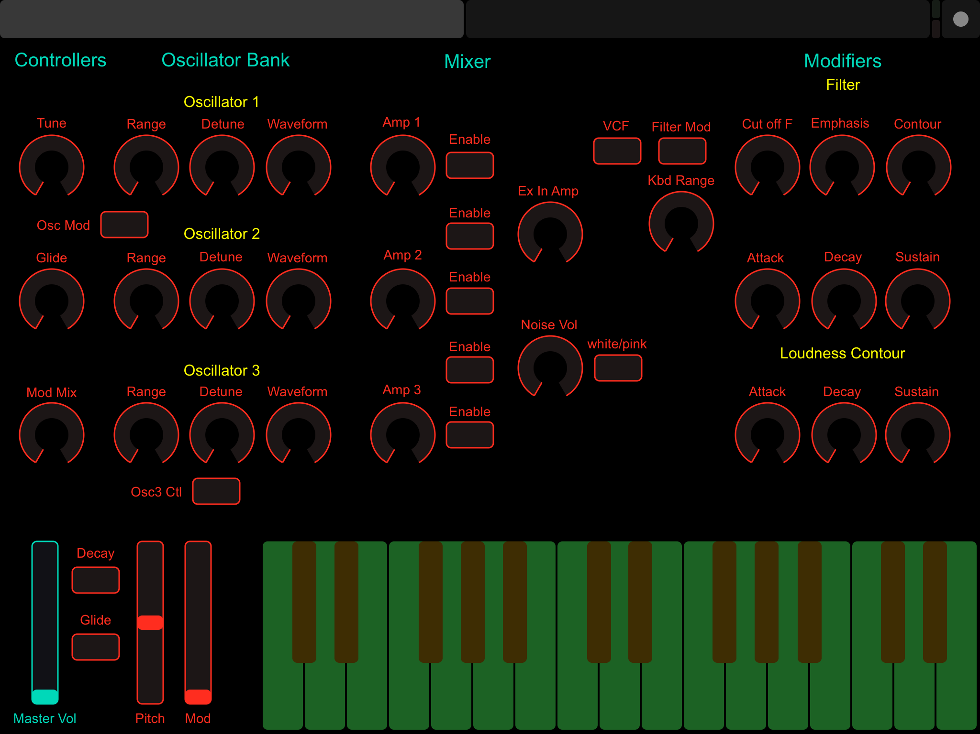

The Effects Chain Page:

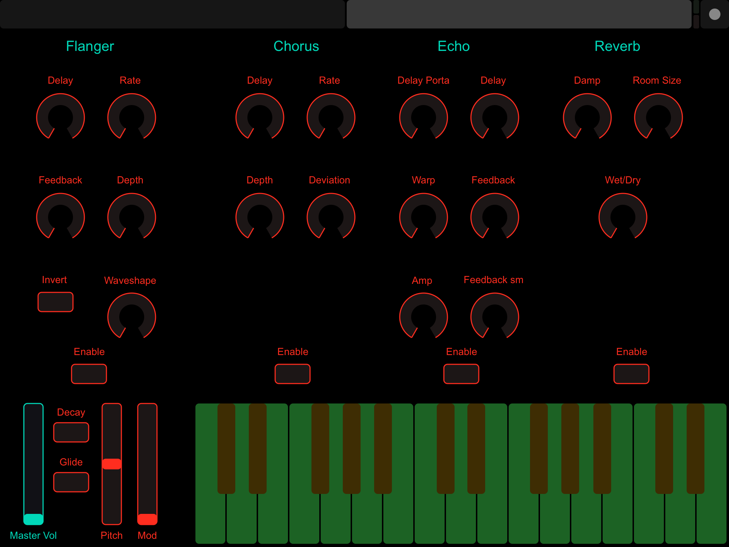

# Conclusion

The Faust library provides a rich set of audio DSP objects that can be used in creating DSP algorithms. Using Faust, it is possible to quickly create large algorithms that take advantage of the computing power available on the SHARC Audio Module platform.